- Purpose

  - The purpose of this procedure is to provide a detailed set of instructions for Supervisors & Managers on how to complete new hire paperwork.

- Scope

  - The scope of this procedure encompasses steps for completing new hire paperwork after all pre-employment requirements have been satisfied. The CPG Application, Interview Notes, and Background Check Release were submitted to begin the hiring process. This procedure begins once the hiring manager has been given approval from HR to hire the candidate (which is after the physical & drug screen results are received).

  - This procedure provides instructions on the following steps:
    - Where to find all required new hire paperwork
    - Which forms need to be completed and submitted to HR
    - Detailed instructions on how to complete the I-9 form
    - How to submit all completed paperwork to HR for processing

- Procedure

  - In order to complete their paperwork, new hires must have a Voided Check, their Social Security card and their I-9 Documents (see Page 9 of the I-9 form for a list of acceptable documents). Unless told otherwise, hire dates will be on a Monday.

  - All new hire paperwork can be found on the server at Human Resources\Public\HR Forms\New Hire Packets. From here, open the folder for the appropriate State and then open the sub-folder that describes the employee’s status (Exempt, Hourly, or SNE—salaried non-exempt). See below.

  - The paperwork required for new hires varies based on the employee’s status. Print all paperwork in the folder unless noted below. Follow directions for each form as detailed for each packet (EE = Employee):

3.3.1 – Hourly Packet

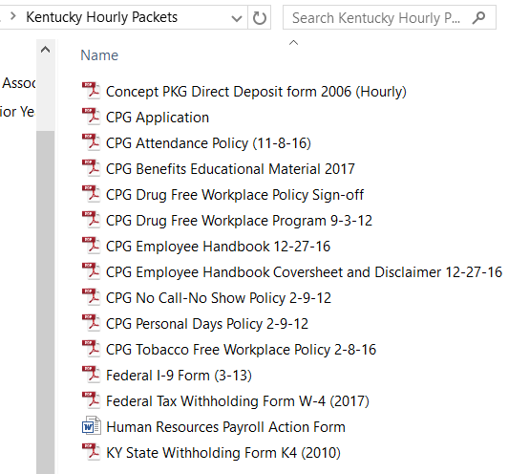
EE completes and attaches their voided check
Do not print - This should already be on file
EE signs and keeps a copy
For EE to keep – Print or Email to EE
EE signs
For EE to keep – Print or Email to EE
For EE to keep – Print or Email to EE
EE signs page 2 (Disclaimer)
EE signs and keeps a copy
EE signs and keeps a copy
EE signs and keeps a copy
See instructions at the end of this procedure
EE completes form
EE--Personal Data section & sign / Supervisor--Org Info/Pay Data/sign
EE completes form for their state of employment

3.3.2 – SNE (Salaried Non-Exempt) Packet

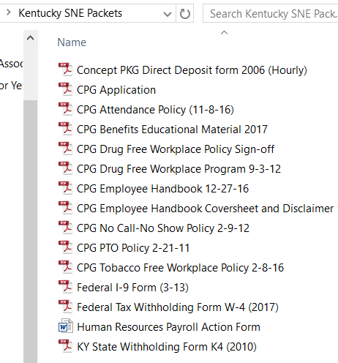
EE completes and attaches their voided check
Do not print - This should already be on file
EE signs and keeps a copy
For EE to keep – Print or Email to EE
EE signs
For EE to keep – Print or Email to EE
For EE to keep – Print or Email to EE
EE signs page 2 (Disclaimer)
EE signs and keeps a copy
EE signs and keeps a copy
EE signs and keeps a copy
See instructions at the end of this procedure
EE completes form
EE--Personal Data section & sign / Supervisor--Org Info/Pay Data/sign
EE completes form for their state of employment

3.3.3 – Exempt Packet

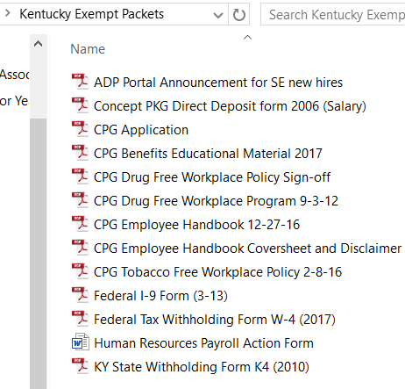
Informational purposes only – print or email to EE
EE completes and attaches their voided check
Do not print - This should already be on file
For EE to keep – Print or Email to EE
EE signs
For EE to keep – Print or Email to EE
For EE to keep – Print or Email to EE
EE signs page 2 (Disclaimer)
EE signs and keeps a copy
See instructions at the end of this procedure
EE completes form
EE--Personal Data section & sign / Supervisor--Org Info/Pay Data/sign
EE completes form for their state of employment

  - The I-9 form is very important as the information gets entered into the Department of Homeland Security’s E-Verify system. You can complete the form in one of two ways: 1) Complete it electronically, then print for signatures; or 2) Print a blank form and complete all by hand. Completing it electronically will limit the chance for errors.

    - Click on this link for examples of documents and example pictures for list A, B & C:
http://www.uscis.gov/i-9-central/acceptable-documents

    - You must physically handle the documents and inspect them for authenticity (a copy is not sufficient). Click on this link for guidance should you question the authenticity of a document:
http://www.uscis.gov/i-9-central/acceptable-documents/examining-documents

    - A new hire must provide a document from List A, or a document from both Lists B & C. For example, they can provide a U.S. Passport (List A), or a state Driver’s License (List B) and a Social Security Card (List C).

    - Scan (in color) the documents used to complete the form and submit them with all other paperwork.

    - NOTE: Do not white-out or black-out errors to correct them. Simply draw a line through the error and write above it. You can opt to initial and date the correction.

    - For additional, detailed instructions, click on the box at the top of the form.
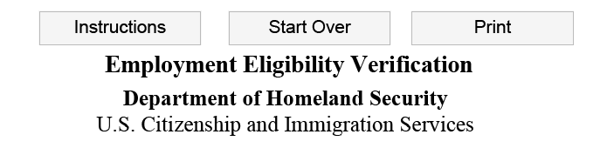

    - For additional tips and training, review this CPG HR PowerPoint:

  - Once all paperwork is complete, scan it all as one document and submit it to the HR Support Desk by emailing hrsupport@concept-pkg.com and attaching the file. You should submit all of the following:

    - Direct deposit form with voided check
    - I-9 form with color copies of documents (hint: a phone picture works, and you can email it separately if needed)
    - Color copy of SS card (if not used for I-9) – this is a requirement of Payroll for tax purposes
    - Federal withholding tax form
    - State withholding tax form (if applicable)
    - Payroll Action Form
    - Signed policy acknowledgements

