- Purpose

  - The purpose of this procedure is to provide a summary of important forms that Managers, Supervisors, and Leads, may use as part of their leadership role.

- Scope

  - The scope of this procedure applies to Managers, Supervisors, and Leads that may be required to use these forms for circumstances that may involve themselves or their employees. It briefly summarizes the purpose of each form and details where each form is located.

- Forms

  - PAF
    - PAFs are used when you have a new hire, a termination, personal data changes, or when you have an employee changing jobs. Once completed, these are submitted to the Accounts Payable Clerk for your region. For more in-depth details on how to complete a PAF please see procedure ‘HR-37 Job Changes (Promotions—Demotions—Transfers)’ and ‘HR-40 Terminations’.
        - PAFs can be found on the server at \\georgetown\shared\Human Resources\Public\HR Forms\Payroll Forms & Examples\Payroll Action Form (PAF)

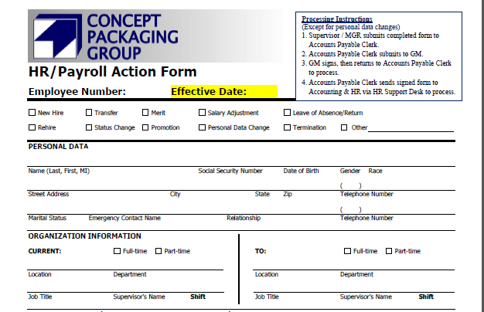

  - Performance Review
    - Performance review forms are used when giving a 60-day review to new hires or employees who have changed jobs (unless they moved up in Finishing, Assembly or Press). They are also used when giving annual performance reviews.
        - 60-day performance reviews can be found on the server at \\georgetown\shared\Human Resources\Public\HR Forms\Performance Reviews\60-day Review Forms

        - Annual performance reviews can be found on the server at \\georgetown\shared\Human Resources\Public\HR Forms\Performance Reviews\Annual Review Forms

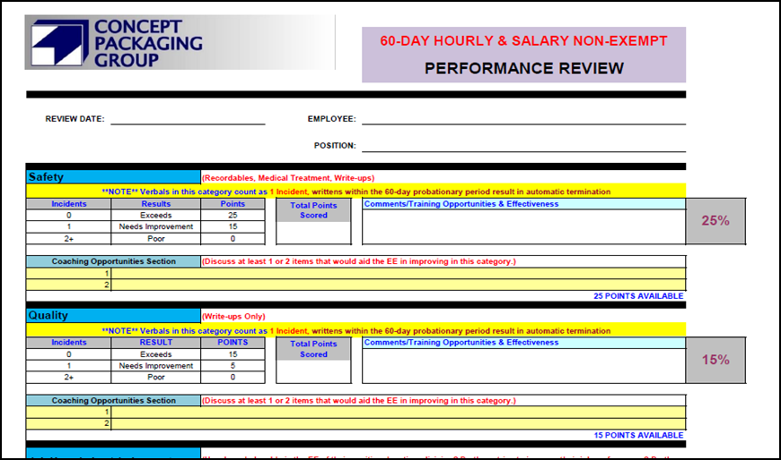

  - 401k Enrollment Forms
    - 401k enrollment forms are due 6 months after an employee has been hired with CPG. For more in-depth details on how to complete 401k enrollment forms please see procedure ‘HR-28 CPG 401k Enrollment Completion Process’
        - 401k forms can be found on the server at \\georgetown\shared\Human Resources\Public\HR Forms\401k Forms

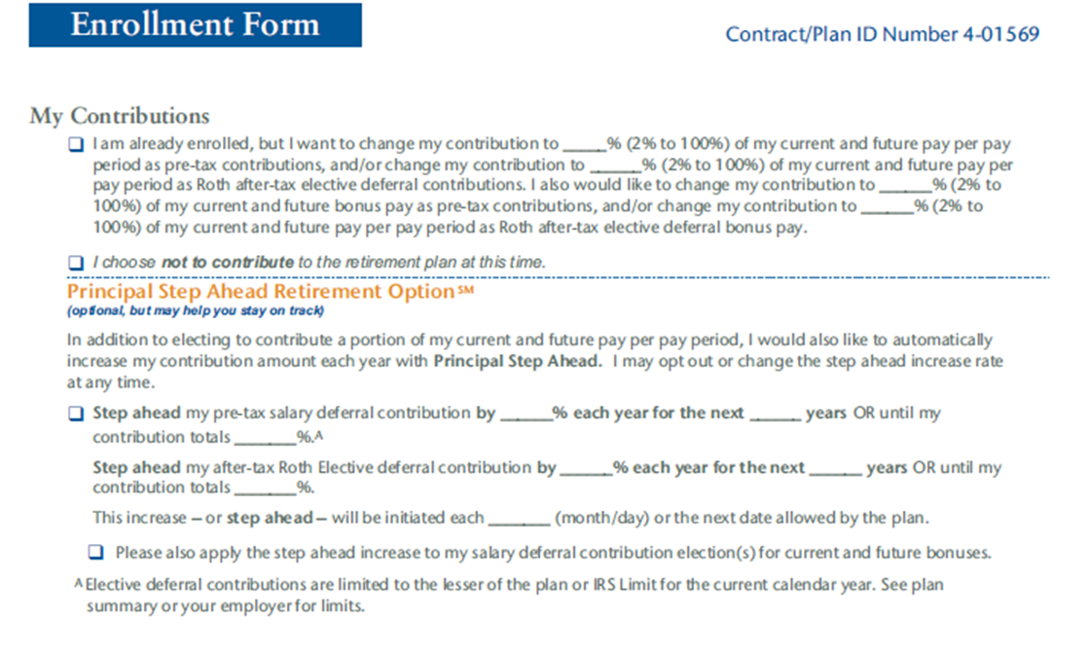

  - Kroll Disclosure Form
    - Kroll Disclosure Forms are the background release forms that potential new hires sign to give consent for a background check. They are also used for consent for CPG to run a driver history check on employees that will be driving CPG vehicles.
        - Kroll forms can be found on the server at \\georgetown\shared\Human Resources\Public\HR Forms\Background Checks

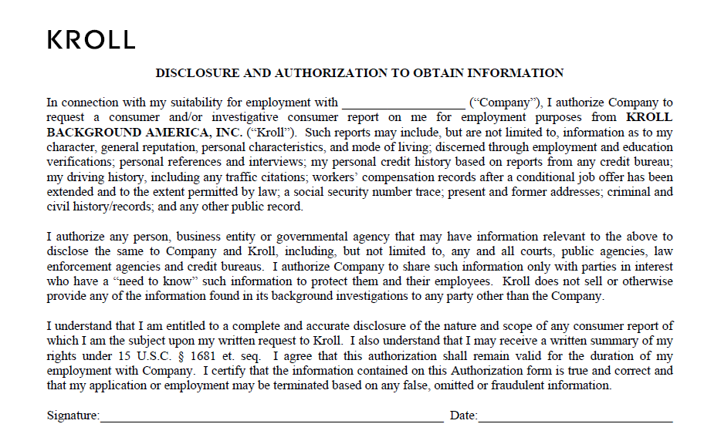

  - CPG Application
    - The CPG application is completed by potential new hires after being offered a position at CPG.
        - The CPG application can be found on the server at \\georgetown\shared\Human Resources\Public\HR Forms\New Hire Packets

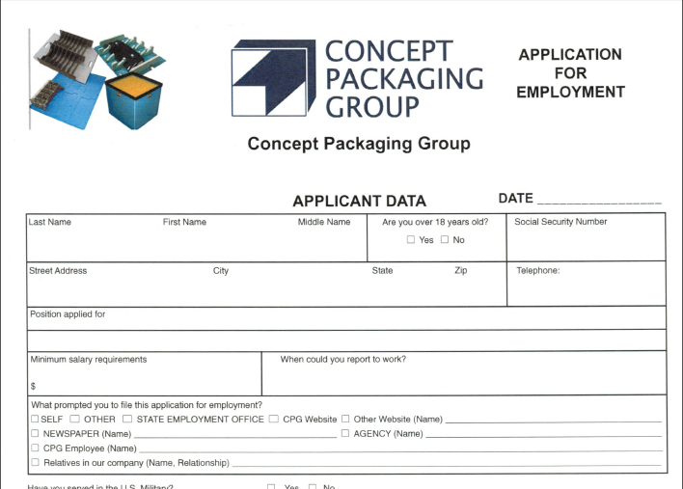

NOTE: The Kroll Disclosure Form and the CPG Application are both completed post-offer.

  - Interview Notes & Checklist
    - The interview notes and checklist are used when interviewing potential new hires and assists with communicating important new hire information to applicants. These forms are submitted to HR with the background release and the CPG application in order to start the hiring process.
        - The interview notes and checklist can be found on the server at \\georgetown\shared\Human Resources\Public\HR Forms\Interview Forms

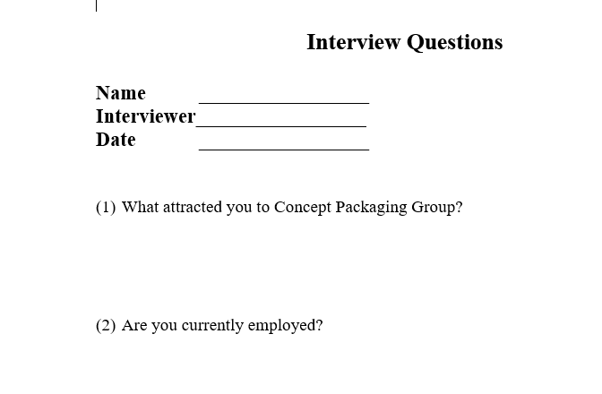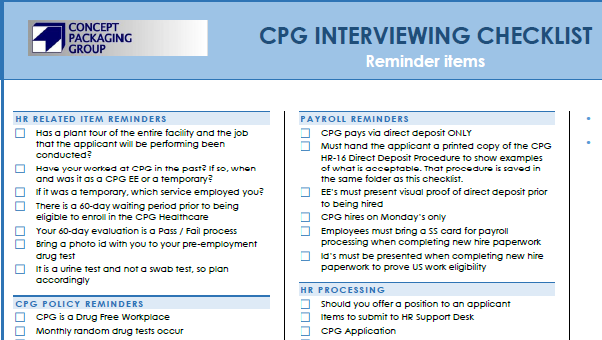

  - Employee Counseling Forms
    - Employee counseling forms are given to employees when they are issued verbal or written counselings, and they are also used for terminations.
        - Counseling forms can be found on the server at \\georgetown\shared\Human Resources\Public\HR Forms\Counseling Forms. This folder also includes sample counselings that can be used to help assist in creating an employee counseling.

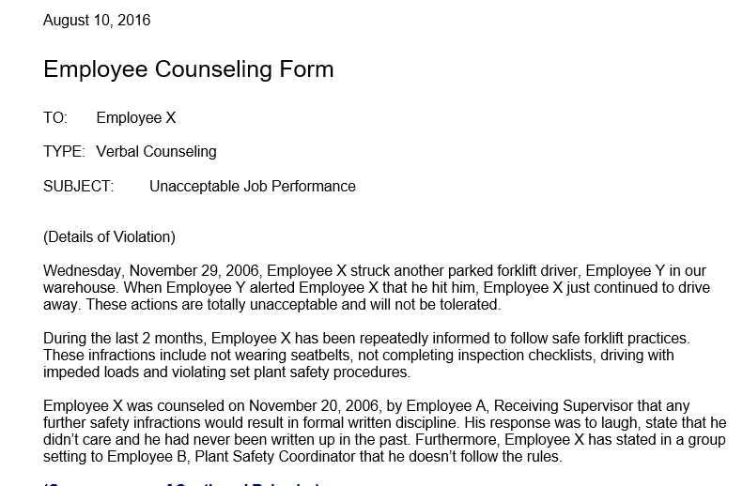

  - Healthcare Enrollment Form
    - The Healthcare Enrollment form is due 2 months after an employee has been hired with CPG. It is also used when an employee has a life-changing event and needs to enroll onto CPG’s healthcare plan. For more in-depth details on how to complete Healthcare enrollment forms please see procedure ‘HR-17 CPG Health Care Enrollment Form Completion Process’.
        - Healthcare enrollment forms can be found on the server at \\georgetown\shared\Human Resources\Public\HR Forms\Health Care\Enrollment Forms

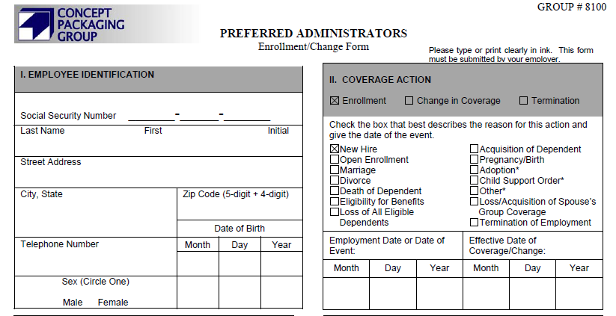

  - FMLA & ICP Forms
    - FMLA and ICP forms are used when employees need to take time off from work for a serious health condition or an immediate family member’s serious health condition. For more information about when and how to use these forms, please see procedure ‘HR-31 FMLA-ICP Completion’.
        - FMLA and ICP forms can be found on the server at \\georgetown\Human Resources\Public\HR Forms\Medical Leave (FMLA & ICP)
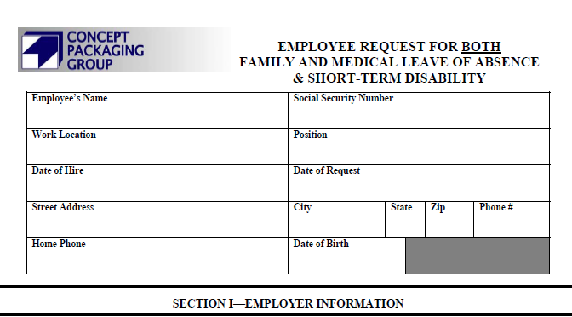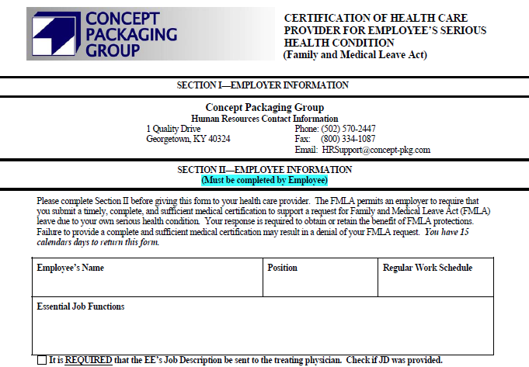

  - New Hire Packets
    - New hire packets include all of the new hire paperwork that new hires need to complete before they can become an employee of CPG. These items should be completed once HR notifies you that the potential new hire has completed all of their pre-employment items. External hires will complete these forms on their first day of employment.
        - 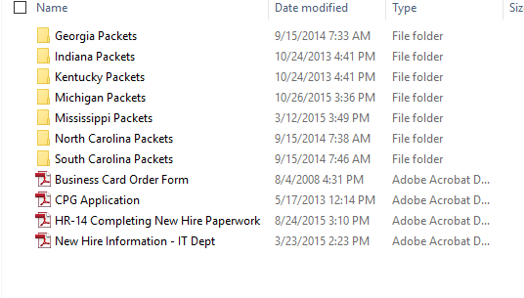New hire packets can be found on the server at \\georgetown\shared\Human Resources\Public\HR Forms\New Hire Packets

  - Direct Deposit Form
    - The direct deposit form is used for new hires when completing their new hire paperwork and it is also used when an employee needs to make changes from their original form.
        - The direct deposit form can be found on the server at \\georgetown\shared\Human Resources\Public\HR Forms\Payroll Forms & Examples\Direct Deposit
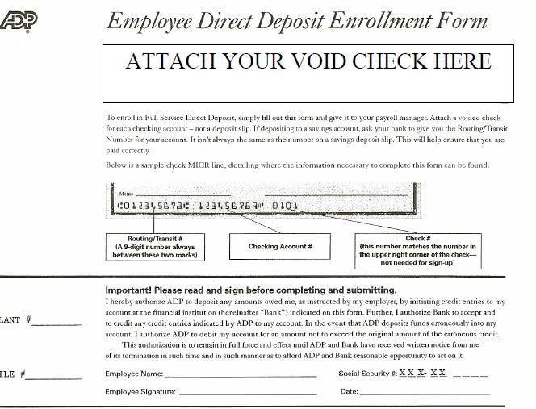

  - Tax Withholding Forms
    - Tax withholding forms are used for new hires when completing their new hire paperwork and it is also used when an employee needs to make changes from their original form.
        - Tax Withholding forms can be found on the server at \\georgetown\shared\Human Resources\Public\HR Forms\Payroll Forms & Examples\Tax Withholding Forms
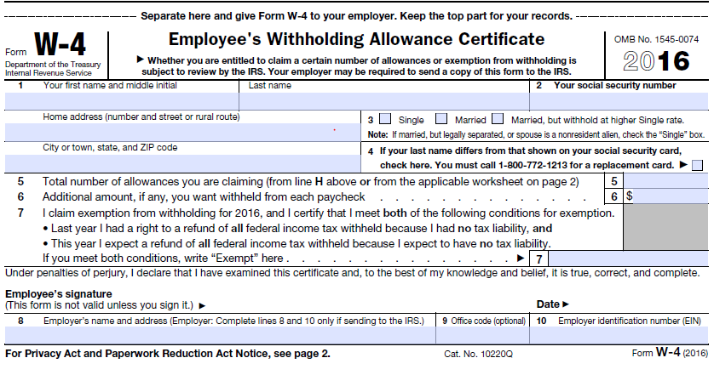

  - Form for Outside Collections & COC (Chain of Custody) Form
    - The form for outside collections and the COC form are forms used when an applicant goes for a pre-employment drug test, post-accident drug tests, or random drug tests. If an employee has to get tested for one of these reasons, they must take a COC and this “Form for Outside Collections” to the medical clinic with them.

        - The COC form is outside of the HR office for the Georgetown location. For the Spartanburg location the COC form can be found in the HR office.

        - The form for outside collections can be found on the server at \\georgetown\shared\Human Resources\Public\HR Forms\Medical Clinics\Redpoint Medical.
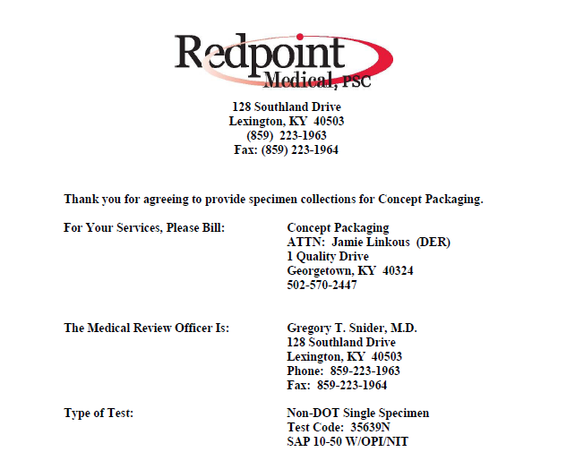

  - Accident Report & Safety Alert Forms
    - Accident Report and Safety Alert forms are used when a workplace injury or property damage has occurred. For more in-depth instructions on how to complete these forms and the important time frames on when to complete these forms, please see procedures ‘HR-33 Accident Report Form Completion’ and ‘HR-34 Safety Alert Form Completion’.
        - The accident report and safety alert form can be found on the server at \\georgetown\shared\Human Resources\Public\HR Forms\Safety Forms
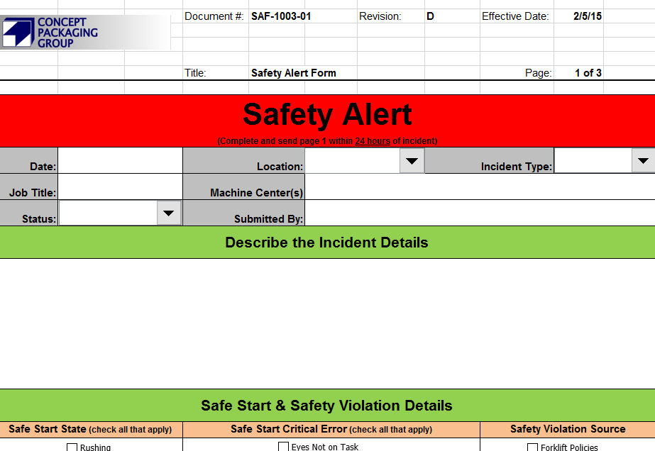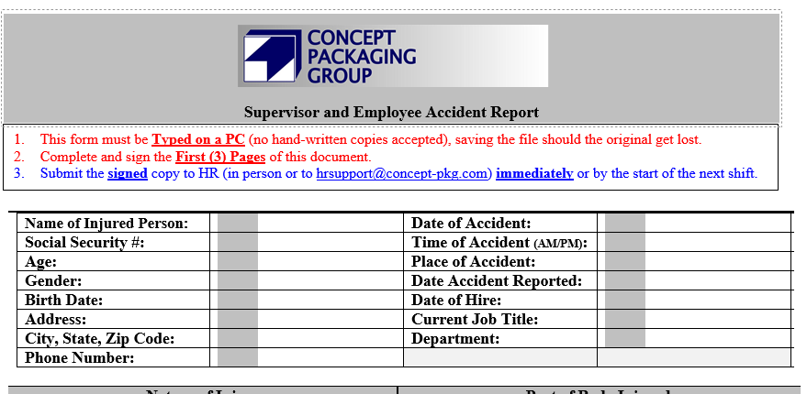

  - Safety Initiative Form
    - Safety Initiative forms are used when an employee has identified an unsafe working condition or when they have an innovative idea that changes a process or completely creates a new way of doing things. After completion, send this form to the HR Support Desk, and Safety Leadership points will be awarded.
        - The safety initiative form can be found on the server at \\georgetown\shared\Human Resources\Public\HR Forms\Safety Forms
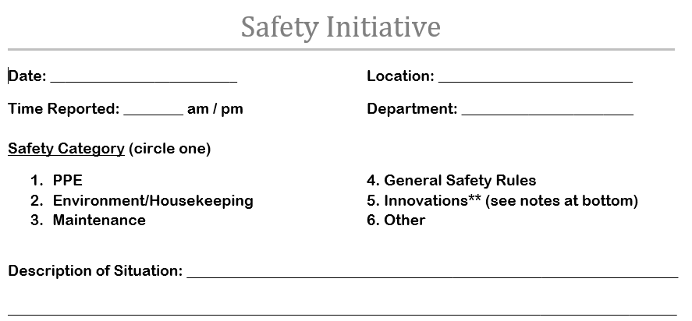

  - EAP (Employee Assistance Program) Flyers
    - EAP flyers are provided for the employee’s benefit and are designed to assist employees in resolving personal problems that may be adversely affecting their personal or work life.
        - EAP Flyers can be found on the server at \\georgetown\shared\Human Resources\Public\HR Forms\EAP Services (Employee Assistance Program)
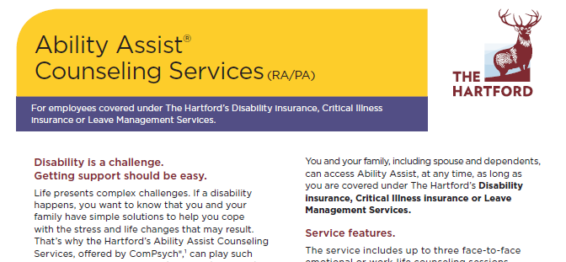

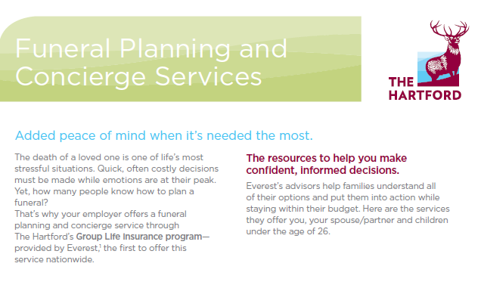

  - Absence & Vacation Form
    - The absence & vacation form is used when employees need to request time off from work, or when employees are absent from work and receives an occurrence. Once completed, these forms are sent to the Accounts Payable Clerk, not HR.
        - The absence and vacation form can be found on the server at \\georgetown\shared\Human Resources\Public\HR Forms\Payroll Forms & Examples\Absence & Vacation Forms

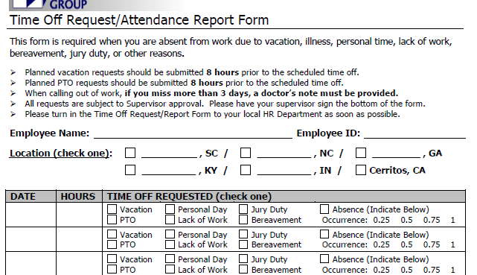

  - New Employee Orientation Training Form
    - The new EE orientation form (QSP6-43) is used when training new hires and is required to be completed within 90 days of the new hire’s hire date. For more in-depth details on how to complete the new hire training form, please see procedure ‘HR-39 Completing Job Training Requirements’.
        - New hire training forms for the SAO can be found on the central shared drive at \\conceptdom\central share\Quality_ScGa\Quality Management System\QSP6 Forms
        - New hire training forms for the NAO can be found on the Georgetown shared drive at \\georgetown\shared\Quality_Ky\QSP6 Forms

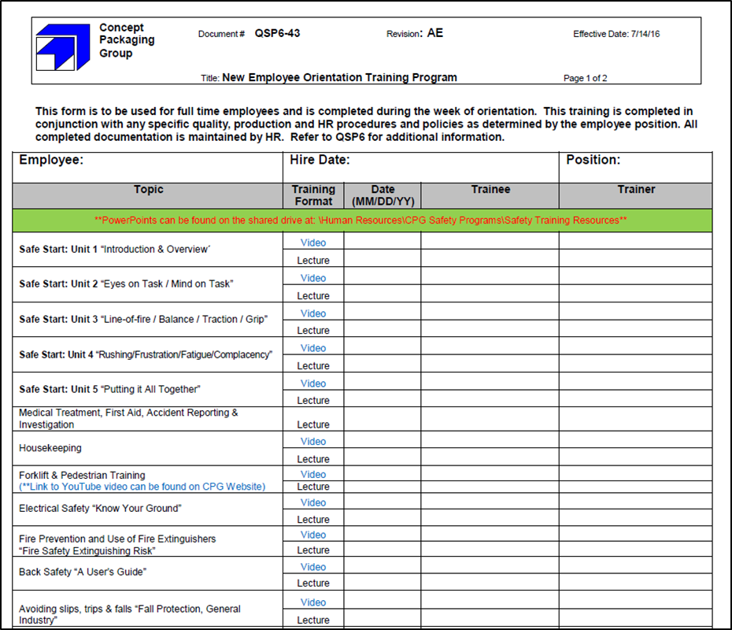

  - Job-Specific Training Form
    - The job-specific training form (QSP6-05) is used when training new hires and employees who have moved to a new position. This training form is required to be completed within 90 days of the date the employee moved positions or 90 days of the hire date if the employee is a new hire.
        - Job training forms for the SAO can be found on the central shared drive at \\conceptdom\central share\Quality_ScGa\Quality Management System\QSP6 Training Requirements
        - Job training forms for the NAO can be found on the server at \\georgetown\shared\Quality_Ky\QSP6 Training Requirements.

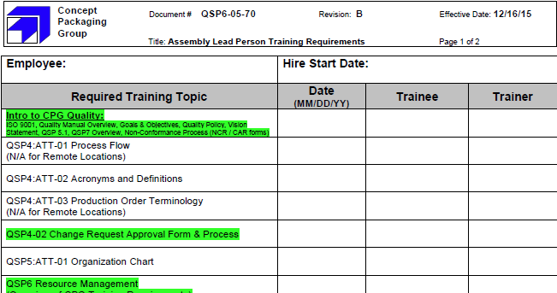

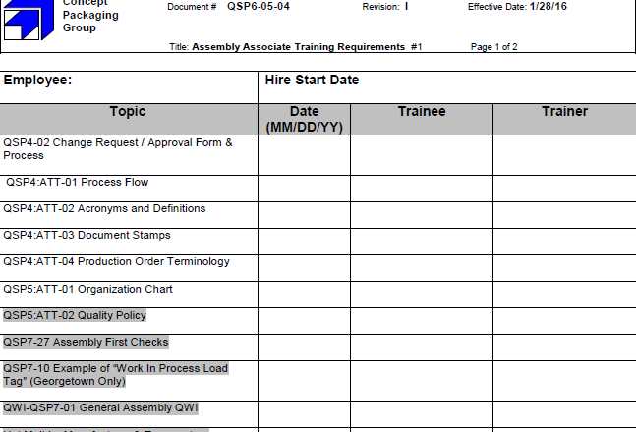

NOTE: Training topics highlighted green or grey are for temporaries that are performing the job of a full-time employee after they have been on assignment for 2 weeks.

For example, if a temporary employee is performing the duties of the Assembly Associate I position above after they have been on assignment here for 2 weeks, full-time training needs for that position needs to be given to the temporary so they can be trained on ONLY those highlighted topics.

