- Purpose

  - The purpose of this procedure is to provide detailed instructions for completing FMLA (Family & Medical Leave Act) and/or ICP (Income Continuation Program) paperwork.

- Scope

  - The scope of this procedure applies to anyone involved with completing FMLA and/or ICP paperwork, including the HR Department, Managers, Supervisors, Leads, and the requesting Employee. It details steps for when the leave involves both benefits concurrently, FMLA only, and ICP only.

- Eligibility
  - Employees are eligible for each type of leave as follows:
  - ICP – after 60 days of employment with CPG (Temporary time worked is not included)
  - FMLA – after 12 months of employment and employee has worked 1250 hours for CPG in the last 12 months (Temporary time worked is included)

- Responsibility & Overview

  - Below is an overview of the steps involved to complete, return, and process FMLA / ICP paperwork.

  - Employee notifies Supervisor of need for FMLA / ICP leave.
  - Supervisor provides paperwork to employee and notifies HR that an employee has requested leave pending paperwork.
  - Employee completes their portion of the paperwork.
  - Employee then gives treating Doctor the paperwork to complete and return.
  - HR reviews the paperwork for completion and notifies necessary CPG personnel of necessary details.
  - The Employee is responsible for keeping HR updated on their leave and return to work date.

- Procedure

  - Step 1: Employee notifies Supervisor of the need for FMLA / ICP leave. There are many reasons why an employee would need to take leave under the FMLA and/or CPG’s ICP benefit:
    - FMLA Only
      - To care for an immediate family member (full time or intermittent leave)
      - To take intermittent leave related to their own serious health condition
      - Military-related leave (see HR for details on qualifying events)

    - ICP Only
      - To take full-time leave as a result of a non-work related medical condition that prevents them from working. Employees that are not yet eligible for FMLA will be on ICP leave only.

    - FMLA & ICP
      - To take full-time leave as a result of a non-work related medical condition that prevents them from working, and the employee meets the criteria for FMLA eligibility.

  - Step 2: Supervisor provides paperwork to employee.
    - Paperwork is on the server as shown below. Depending on the type(s) of leave that will apply, open the corresponding folder and print all of the documents in that folder.
    - NOTE: For “FMLA Only”, you will only need to print one Health Care Provider Form depending on if the leave is due to their own or a family member’s health condition.

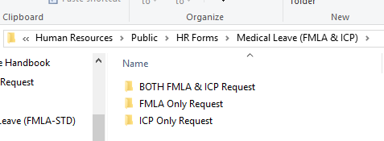

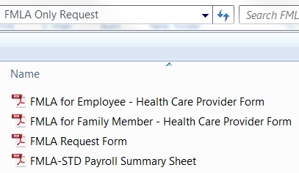

Only print one of these two forms, as applicable.

    - If the leave is for the EE’s medical condition, print a Job Description for the Doctor to review, which is located on the server as shown below:

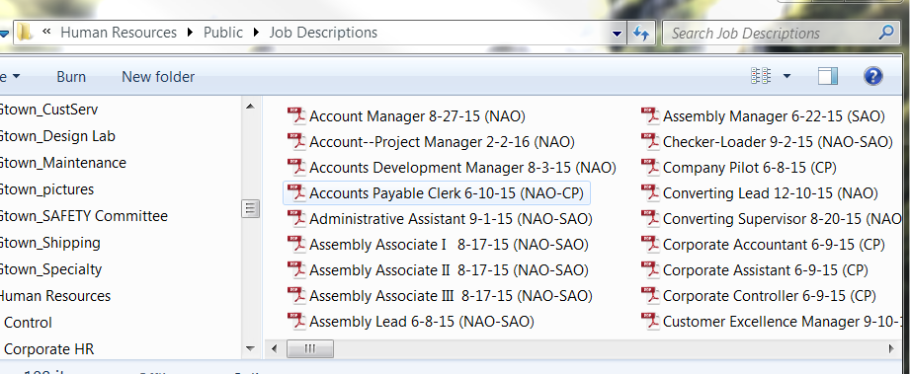

    - Notify HR that an employee has requested FMLA and/or ICP leave, pending paperwork.

  - Step 3: Employee completes their portion of the paperwork. NOTE: All paperwork (from the EE and the Doctor) must be returned to HR within 15 calendar days of the initial request for leave.
    - Each section of the form is clearly marked with who is responsible for completing that portion:
      - Employees complete the blue sections.
      - Doctors complete the green sections.
      - Human Resources completes the yellow sections.

  - Step 4: Employee then gives treating Physician the paperwork to complete and return to HR via fax.

  - Step 5: HR reviews the paperwork for completion and notifies Payroll, IT, and Supervisors of necessary details.

  - Step 6: The Employee is responsible for keeping HR updated on their leave and return to work date.
    - HR is responsible to update CPG personnel as necessary.

