- Purpose

  - The purpose of this procedure is to provide detailed instructions for properly reporting a No Call/No Show (NCNS).

- Scope

  - The scope of this procedure applies to Managers, Supervisors, and Leads that need to report a NCNS. It details the NCNS policy, the process of reporting a NCNS, and the consequences of the NCNS.

- Responsibility
  - Managers, Supervisors, and Leads are responsible for reporting a NCNS if their employee doesn’t notify them of an absence.

- Policy

  - A No Call/No Show is defined as being absent from one’s shift, or otherwise scheduled work day, without notifying the supervisor or manager within the first 2 hours of the shift.
    - If an employee calls in and says that they will be late, then never shows up, they are considered a NCNS.
    - If a night shift employee calls during the day to notify someone of an absence, it is still necessary to call back the same evening and talk to their supervisor or manager directly.
    - In non-emergency situations, it is important that the employees themselves notify their supervisor, lead, or manager and not a friend or family member.
    - If initially the employee is unable to get in contact with their supervisor, they must leave a message and include the number where they can be contacted.
        - Despite leaving a message, they are still required to continue calling until they can reach their supervisor.

  - Using a social media format to inform a supervisor of an absence is not and will not serve as a substitute for calling in and speaking with the supervisor/manager.
    - Examples of a social media format include but are not limited to emails, texts, Facebook, Twitter, etc. Any employee who uses a social media format as the only means of informing their supervisor will still be in violation of the NCNS policy.

  - If an employee has agreed to work a shift other than their regularly scheduled shift, they have effectively revised their schedule and are now obligated to call if unable to work that shift.

5.0 Procedure

5.1 If the employee has not called their supervisor within 2 hours of the start of the shift, notify the HR Support Desk (HRSupport@concept-pkg.com), explaining the details of the absence.
    - It is important to notify HR immediately because otherwise there is no way of knowing that an absence was a NCNS unless it is reported directly to them. This also allows HR to notify payroll to prepare for the employee’s final paycheck in a timely manner.
    - Once notified, HR will write a written counseling and send it back to the supervisor so that it will be reviewed and signed by both the supervisor and the employee if the employee returns to work the next day. See screenshots below on the next page.
    - If the employee is also a NCNS for the following day, then the employee is a 2 day NCNS and will be terminated, so a termination PAF needs to be sent to the Accounts Payable Clerk.
      - The effective date on the termination PAF is always the date of the 2nd NCNS, not the date that the PAF actually gets completed.

NOTE: If the employee is within their 60-day probation, they are terminated after the 1st NCNS. The effective date for the PAF will be the date of the NCNS.

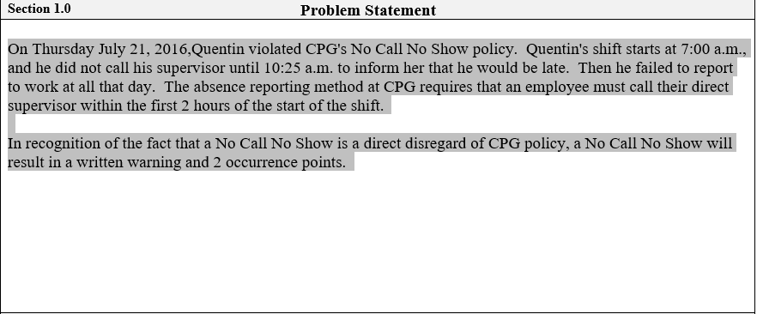

This section of the counseling includes the details that were given to HR about the employee’s absence, and includes the consequences of the counseling.

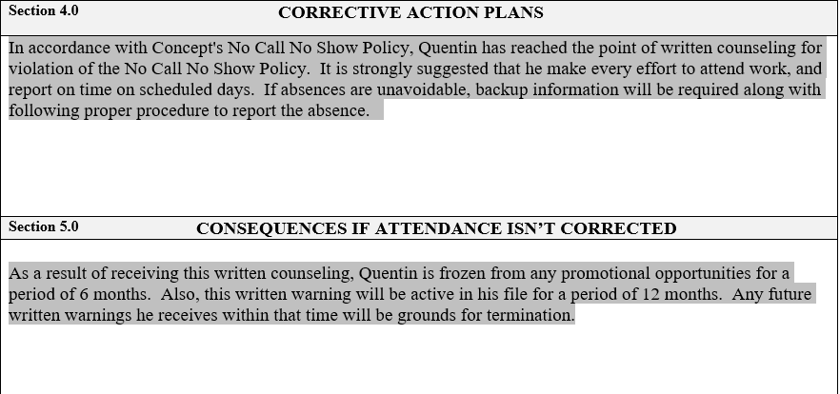
Sections 4.0 and 5.0 of the written counseling provide more details about the consequences of the NCNS, including future consequences if the behavior is not corrected.

The bottom of the counseling should be signed and dated here, and a copy should be sent to the HR Support Desk.
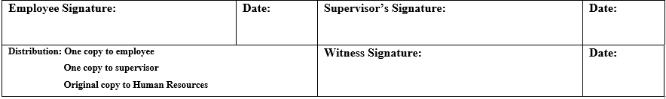

6.0 Consequences of NCNS

6.1 A NCNS will result in a written counseling for the 1st offense.
6.1.1 If an employee receives 2 written counseling’s within a 12-month period, it will be grounds for termination. For instance, if an employee already had a written counseling within 12 months of receiving the NCNS, it will result in a termination.

6.2 Employees who receive a written warning for any reason in the 1st 60 days of employment will be terminated. Since a NCNS results in a written warning, any employee still in their probationary period will be terminated for the 1st offense.

6.3 A NCNS also results in the employee receiving 2 occurrence points for that absence.
6.2.1 If an employee reaches 8 occurrence points, it will be grounds for termination. So if an employee already has 6 or more occurrence points and they receive a NCNS, it will result in a termination.

6.4 A 2nd NCNS offense would be subject to termination, unless good cause for the violations can be shown.

6.5 Employees who are absent from work for 2 consecutive days without giving proper notice to the company will be considered to have voluntarily quit.

