- Purpose

  - The purpose of this procedure is to provide a detailed overview of PeopleTrak screens generally used by those in a Supervisory role.

- Scope

  - The scope of this procedure applies to anyone with access to PeopleTrak that is in a Lead, Supervisor, or Manager position. It details the Personnel Management module of PeopleTrak and what information is included on each screen.

- Procedure

  - After logging in to PeopleTrak, you will see the main screen to access the Personnel Management module. Click on the Open Employee Icon on the left and enter the last name of the EE you need to access, then click search.

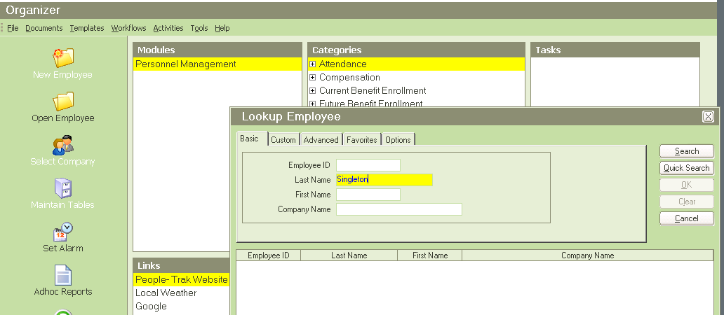
NOTE: If you only click Search, it will bring up the list of ALL the EEs you have access to, and you can select from there.

  - The EE’s record will open to the Personal Screen, which shows their basic contact information. Clicking the Emergency and Exams buttons on the right side will reveal more information as shown below.
    - Note: You should see all text in gray, which is view-only (not blue as shown). **Should you ever see text in Blue, DO NOT delete it, and inform HR.

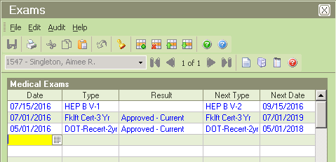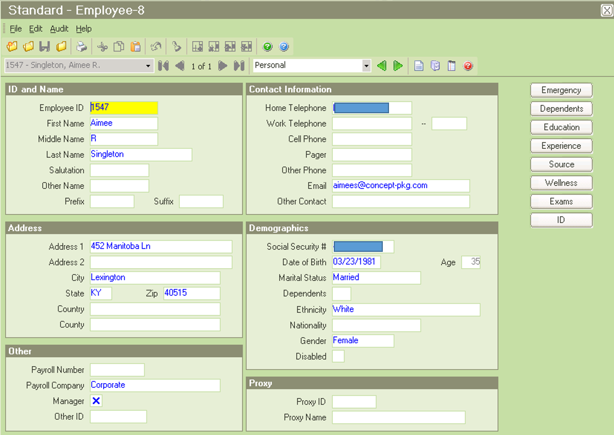
Click to see EE’s History on Hep B vaccinations, and Forklift & DOT certifications.
Click to see EE’s Emergency Contact Info.

  - Use the green arrows at the top of each screen to scroll to the Status screen. This shows employment status history and hire / rehire dates. Click on the Event History and Property buttons to reveal more information as shown below.
Scroll between screens using these arrows.
**Another way is to click on the Page Up and Page Down buttons on your keyboard.
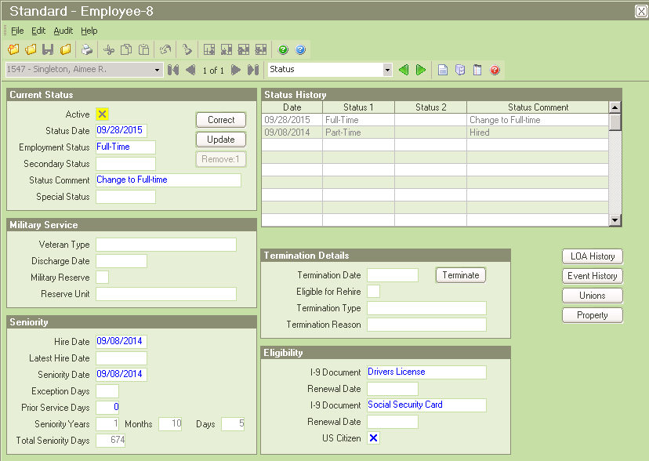
This is where the IT dept tracks any technology items issued by CPG.
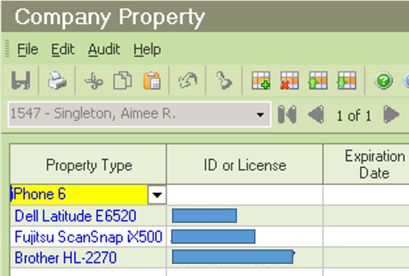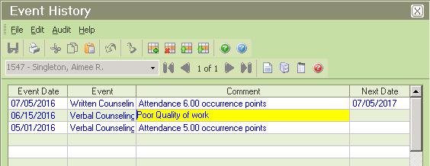

This shows a history of any counselings or accidents.

  - The Compensation screen shows Current Pay on the top left section, and a complete Pay History at the bottom of the screen.

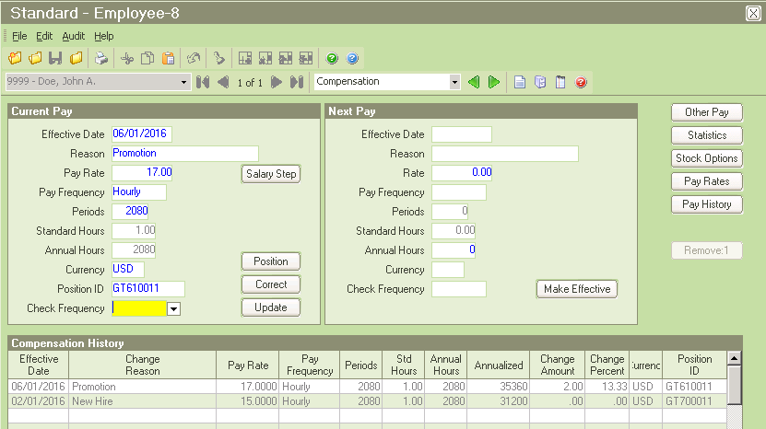

  - The Position History screen shows the Current Position in the top left section, and a complete Position History at the bottom of the screen. To see more information about a job, click on the position and select the Details button as shown below.

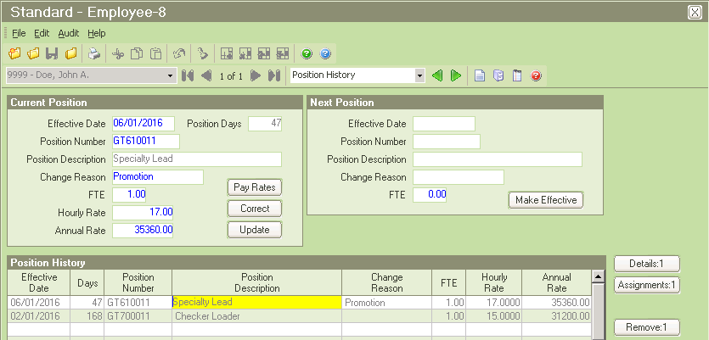

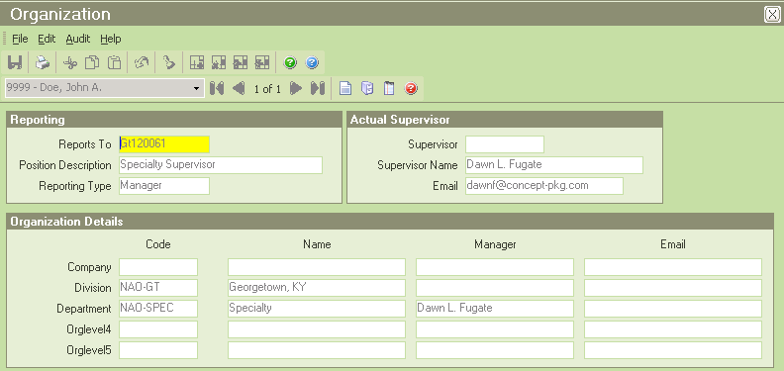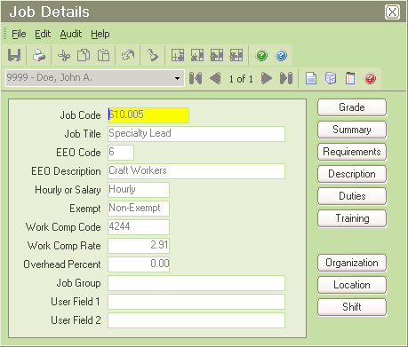
Click Organization to see the Division and Department the job is in, and the Supervisor’s name.
Details include if a job is Hourly or Salary, and if they are Exempt (from OT pay) or Non-Exempt (eligible for OT pay).

  - The Performance screen shows the detailed history of Performance Reviews. To view the actual Review Document, click on the Notes icon at the top of the screen as shown below. This Notes screen also shows Counseling Documents.

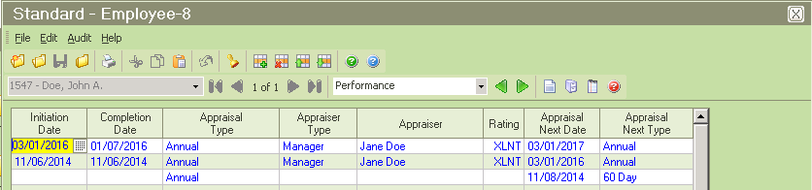
Once on the Notes page, click on a line and select the “Show” button to view the Review or Counseling Document being referenced.

Click the “All Notes” button to view notes and attachments for all screens on the EE’s record.
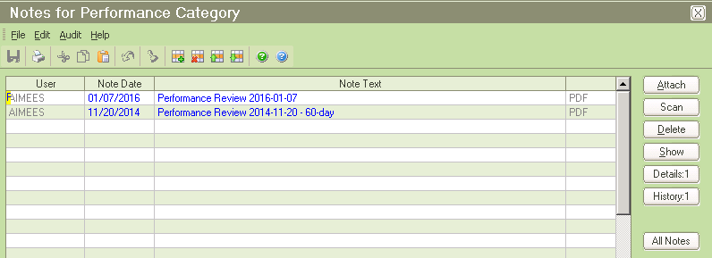

  - The Benefits screen shows the current Healthcare plans the employee is enrolled in and the amount of paycheck deductions.

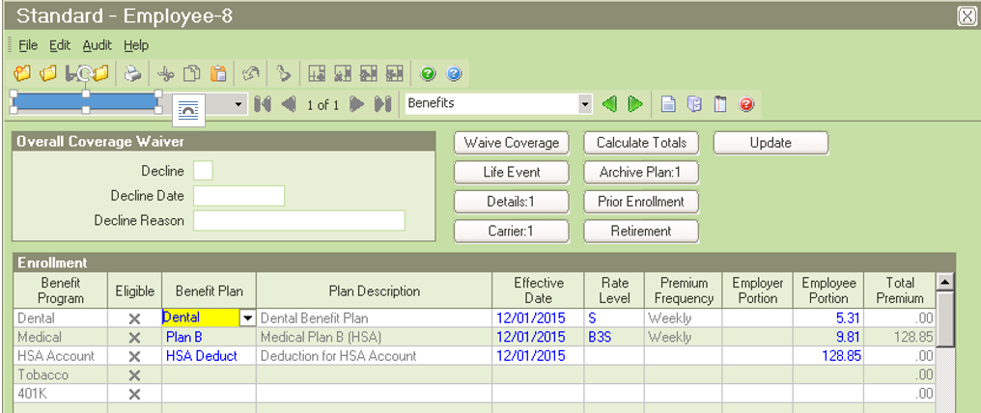

  - The Training / Competency screen shows a history of all training conducted since hired full-time with CPG. Trainings conducted while a Temporary EE will not be listed here. To view the EE’s completed Job-Specific Training Document (Form QSP6-05), click on the Notes icon at the top of the screen as shown below.

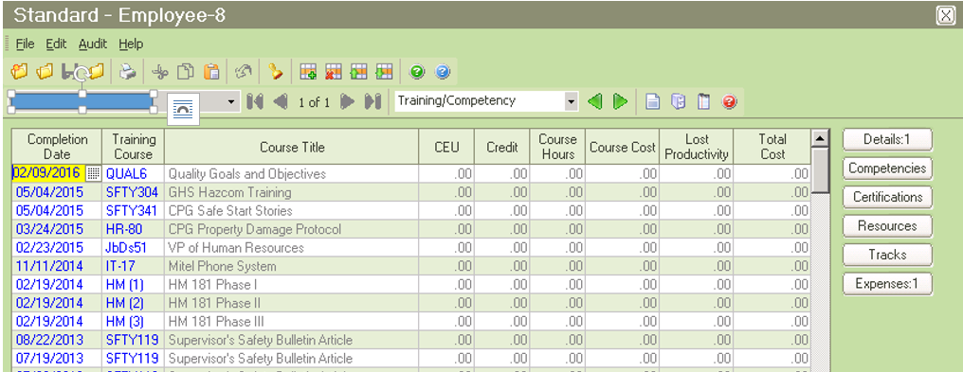
Once on the Notes page, click on a line and select the “Show” button to view the QSP6-05 Training Document being referenced.

Click the “All Notes” button to view notes and attachments for all screens on the EE’s record.
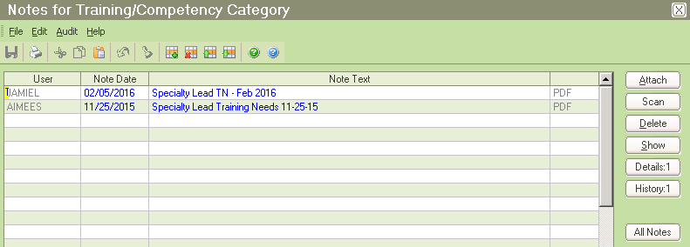

  - The Attendance screen shows all types of Accounts the EE is eligible to use for time away from work, including Vacation, FMLA, STD etc. To view History details about any account, click on the line and select the History button, as shown below with the OCCR account.
    - The Current Balance column shows the amount of hours still available for Leave accounts.
    - The OCCR Balance shows their occurrence points for the year.
    - The SFTYLD Balance shows their current points earned under the Safety Leadership Program. Multiply this number by $0.10 to calculate the bonus amount to be received (which is subject to change throughout the year with additions and deductions). If an EE’s employment with CPG ends on good terms, and they serve a 2-week notice, they will receive this bonus on their last paycheck.

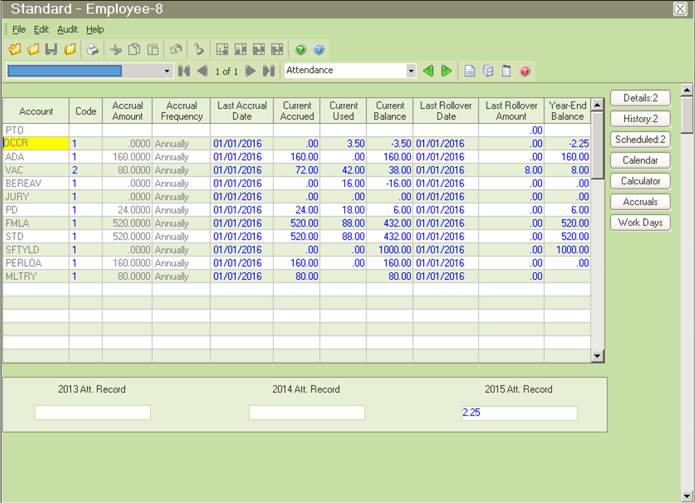
This area shows a 3-year history of the EE’s final Occurrence Points for the years referenced.
Select an Account line and click the History button to see details about that Account.
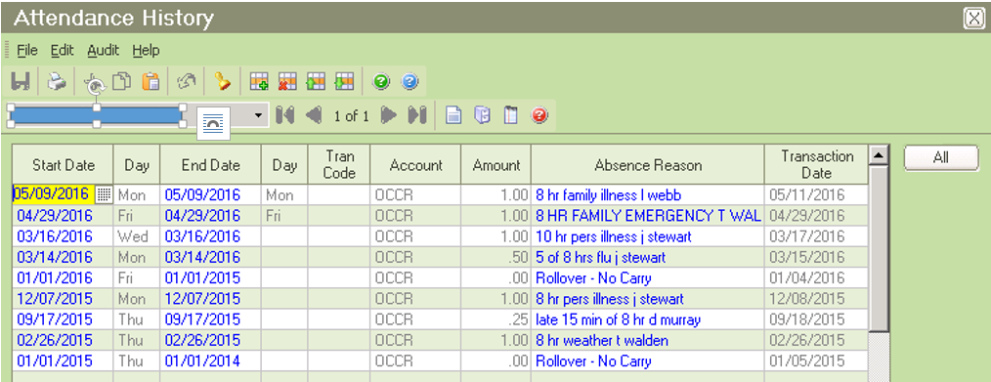

Once on the History screen, you can click the “All” button to view history for all accounts.

