- Purpose

  - The purpose of this procedure is to provide detailed instructions for writing a new Job Description.

- Scope

  - The scope of this procedure applies to Managers and Supervisors who need to create a new position in their department. A Job Description must be drafted and approved before the HR Department will begin the recruiting process.

- Procedure

  - The Department Manager and General Manager approve that a new position needs to be created and filled.

  - The Hiring Manager checks existing Job Descriptions (JD) to see if the job exists in another location. All active JDs are available on the server as shown below:

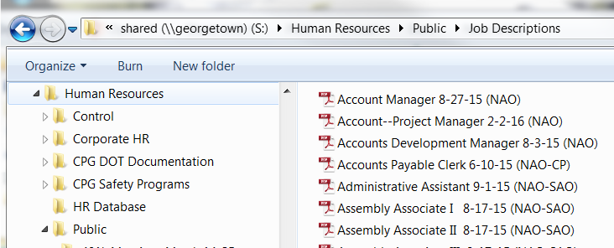

  - If a JD exists for another location, read the JD to make sure it generally applies to your facility.
    - If it does generally apply to your new position, inform HR that you need to post the position. Procedures HR-29 and HR-30 address the remaining steps involved in the hiring process.

  - If a JD exists for another location but you need to make changes, you must get involvement from both regions and follow the approval process at the bottom of the JD form (and step 3.13 below) in order to change the existing JD.

  - If a JD does not exist for another location, request a JD Template from the HR Department (which is an Excel file).
    - You can also request the Excel version of existing JDs that you may want to use as a starting point for ideas for your new JD. You can copy and paste from existing files to your new template.

  - Once you have the files you need, begin drafting your new JD on the template provided. There are three (3) tabs at the bottom of the Excel Template. First, read the Instructions Tab for an overview of the form. Until further notice, Step 3 is not applicable to writing a Job Description. (This applies to hidden tabs that do not need to be completed at this time.)

  - Next, complete the Job Requisition Tab. This will help you define the Essential Job Functions and create the framework for the final Job Description. There are many guidelines and tips to make it simple to draft a JD.

  - Now move on to the Job Description Tab.

  - The first section is shown below, and the only fields you need to complete are starred below.

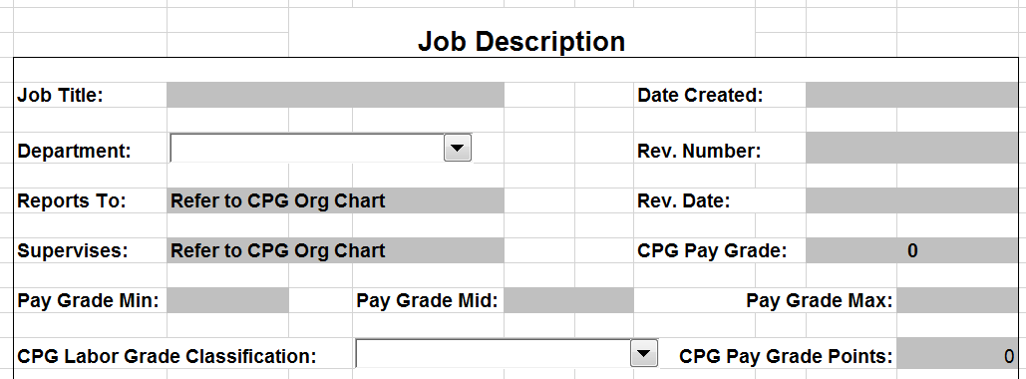

  - The next section is the Summary of the job. This is an overview of the position’s responsibilities, and generally a few sentences is sufficient. You should have drafted the Summary on the Job Requisition Tab to simply copy/paste here. Do not detail the daily tasks here, as that will be addressed in the following section.
    - It is always good to end the paragraph with the phrase “Other Duties as Assigned.”

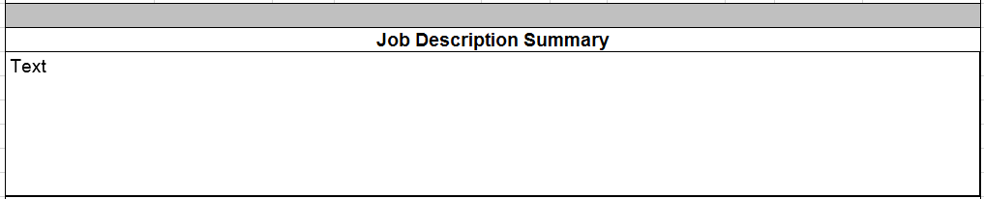

  - The next section defines the Essential Job Functions and provides the details of the regular tasks the position is responsible for. When writing JDs, keep the wording as general as possible so they can apply company-wide and not region-specific whenever possible, and use action verbs throughout this section. You should have drafted the framework for this section on the Job Requisition Tab, so you can now organize it here.
    - The Heading is the general description for a group of tasks that accomplish one major function. Generally speaking, 3-5 Headings are sufficient to label the major functions of a job.
    - Next to each Heading is where you specify the % of time the person will spend on that major function.
      - The % for all Headings needs to total 100%.
      - Each heading needs to be at least 10%, otherwise it is not truly an essential function and can be included with a similar heading.
    - Under each Heading is the beginning of a list for you to detail the tasks that will accomplish the major function. Generally speaking, 5-10 tasks are sufficient to describe the specific tasks of a job function.

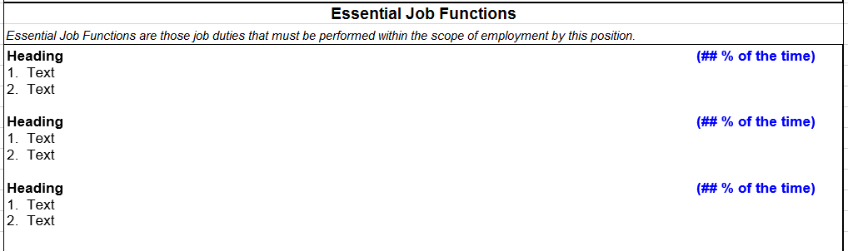
- Keep wording general
- Use Action Verbs for all Headings and Tasks listed

  - The Qualifications are what is preferred for an ideal candidate to possess (not necessarily required). This is a very important section because it is what HR will reference when screening applications. Use the drop-down boxes where provided. For the Knowledge and Skills, be specific as to what an ideal candidate would already possess prior to filling the position.

  - The Physical Demands define what the person must be able to do and how often. This is important as it is what the Physician performing the pre-employment physical will reference. Or, if an employee in the position were to go out on medical leave, their doctor would reference this before releasing them back to work. Be sure that each of the rows have an X on one of the corresponding columns.

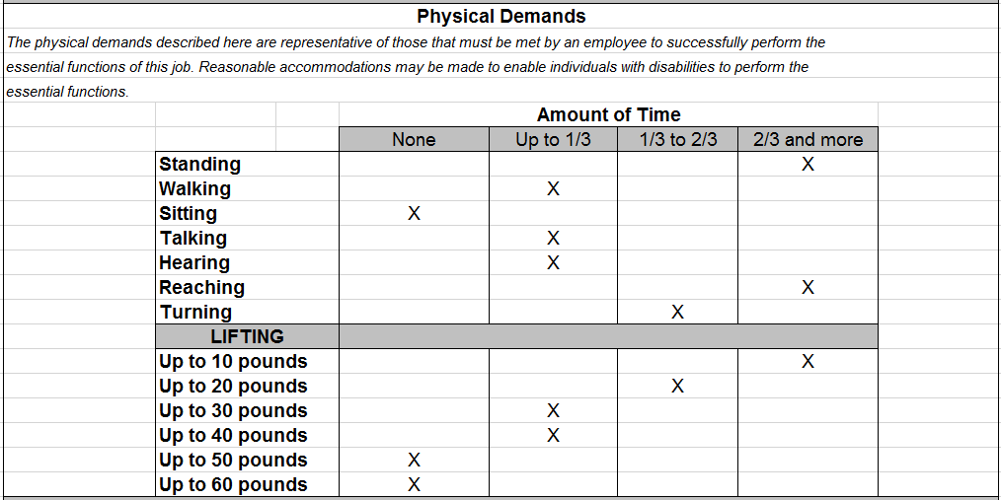

  - The Work Environment is a general description of the environment this position will regularly be exposed to. The example below is a general statement for a production environment. Referencing a pre-existing JD may help you draft this easily.

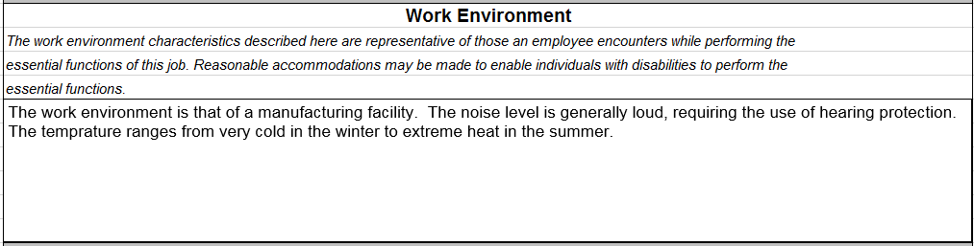

  - The Specific Training section is pre-filled and does not need to be altered.

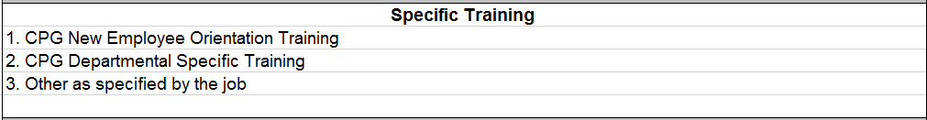

  - Finally, the Approval Process is defined as a flow chart as shown. If the position only applies to your region (NAO or SAO), then the Department Manager (DM) and General Manager (GM) of your region need to approve the JD. If the position will apply to both regions, you must first obtain approval from both regions’ DMs, then both regions’ GMs. The GMs will submit the final version to HR for processing.

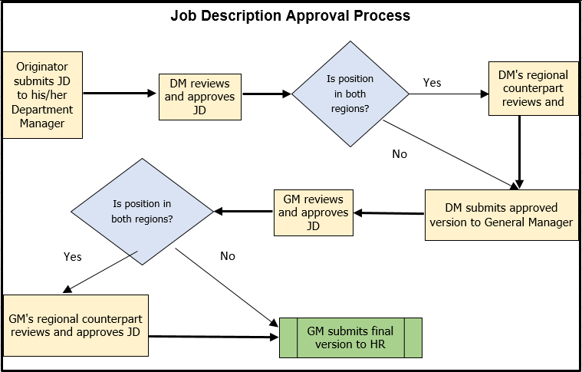

  - HR can now post the position and begin the recruiting / hiring process. Procedures HR-29 and HR-30 address the remaining steps involved in the hiring process.

