- Purpose

  - The purpose of this procedure is to provide detailed instructions for hiring an external candidate.

- Scope

  - The scope of this procedure applies to Managers, Supervisors, and Leads that are filling a position through direct hire (i.e. not a temporary employee).

- Responsibility / Hiring Process Overview

  - The Hiring Manager and the HR Department are responsible for different tasks throughout the hiring process as follows:

  - Hiring Manager creates / confirms Job Description
  - Hiring Manager requests HR to post the job
  - Hiring Manager creates / confirms Job Training Needs
  - Hiring Manager conducts interviews
  - HR sends an offer letter
  - Candidate completes pre-employment items
  - Hiring Manager completes new hire paperwork

- Procedure

  - Step 1: Hiring Manager Creates / Confirms Job Description (JD)
    - Check to see if a JD already exists by going to the JD folder on the server as shown below:

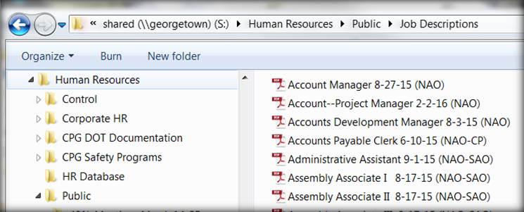

    - Read the JD to make sure it generally applies to your facility.
    - If no JD exists, you can request a template from HR to create a new one.
    - NOTE: HR will not post a job without a JD approved by the General Manager.

  - Step 2: Hiring Manager Requests HR to Post the Job
    - Send an email to the HR Support Desk requesting that the job be posted, including all of the following information:
        - Job Title and Shift
        - Pay Rate (or Pay Range if applicable)
        - Where to post: Internal, External (online), or both

    - Résumés will be routed to HR
        - HR will screen applicants and forward those with relevant experience to the Hiring Manager

  - Step 3: Hiring Manager Creates / Confirms Job Training Needs
    - Work with the Quality Department to confirm or create training needs for the position
    - If training needs exist, confirm that they apply to your location, and work with Quality if any adjustments need to be made to the existing form.
    - If it is a new position, training needs will need to be created and filed with the Quality department.

  - Step 4: Hiring Manager Conducts Interviews
    - As you receive résumés from HR, begin scheduling your interviews as soon as possible.
    - For entry-level positions, there are Interview Questions and an Interview Checklist for you to use that will help guide you conduct the interviews. Those can be found on the server:

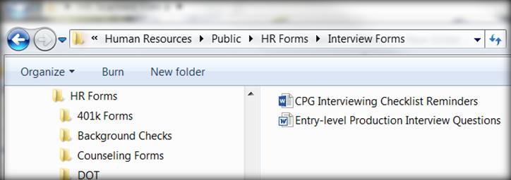

  - Step 5: HR Sends and Offer Letter
    - Send an email to the HR Support Desk requesting an Offer Letter along with the following items:
      - Interview Notes & Interview Checklist attached
      - Résumé attached
      - Job Title, Shift & Starting Pay
      - Projected Start Date (Mondays only, unless Monday is a holiday)

    - HR will email the Offer Letter to the applicant and copy the Hiring Manger
      - The offer letter includes the background check form and a CPG Application.
      - It details instructions for the applicant to return these items and the signed letter to the HR Desk.

  - Step 6: Candidate Completes Pre-Employment Items
    - Background Check
      - HR submits the background check online and notifies the Hiring Manager that it is complete
    - Physical & Drug Screen
      - Hiring Manager will schedule the appointment at the clinic and notify the candidate of the time & location
    - Ready to Hire
      - When medical results are received, HR will notify the Hiring Manager and confirm the start date & time.
      - HR will email the candidate their hire date info, along with a list of items needed for new hire paperwork.

  - Step 7: Hiring Manager Completes New Hire Paperwork
    - Forms and detailed Instructions are on the server (see below)
      - Hiring Manager prints forms for completion
      - Completed forms and other items are sent to the HR Support Desk (details included in instructions)

