- Purpose

  - The purpose of this procedure is to provide a detailed set of instructions for completing a CPG Safety Alert Form.

- Scope

  - The scope of this procedure applies to Supervisors with an employee, vendor, or visitor involved in an accident on CPG property. After conducting the accident investigation and completing the CPG Accident Report Form, a Safety Alert form must be completed and submitted within 24 hours after the accident occurs. This form will be communicated to all CPG employees to serve as a learning tool and hopefully prevent the same or similar accidents from recurring.

Please see “Procedure HR-33 Accident Report Form Completion” for detailed instructions on completing an Accident Report Form within 24 hours after an accident occurs.

- Procedure

  - When completing a Safety Alert Form (SA), keep in mind that this form will be sent to all CPG employees for training purposes. Therefore, do not use the name of the Injured Worker (IW) or any other identifying words related to gender (he, she, him, her).

  - After completing the Accident Report Form, an SA must be completed within 24 hours. This form can be found on the server under \Human Resources\Public\HR Forms\Safety Forms as shown below. Copy the file to your desktop in order to complete the form. The form must be typed, not hand-written.

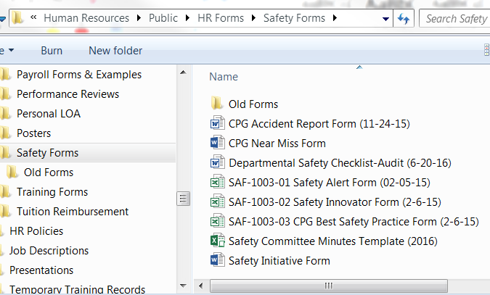

  - Complete the top section, using the drop down boxes where provided. For “Location” there is an “Other” option at the bottom if your location is not currently listed. See notes below for instructions to “Describe the Incident Details”. It may be easier to copy/paste from the Accident Report Form, but be sure that all details are included as shown below.

Include Safe Start verbiage (examples):
“The IW was rushing while…” or

“The IW did not have their eyes on task…”
Use IW for Injured Worker instead of the Victim’s name. Do not use gender identifying pronouns (him/her or he/she).
Describe the incident answering the Who/What/When/Where/How questions.

  - For the next section, check all that apply. The Safe Start data information will come from the Accident Report Form that is answered by the IW. Do not assume you know why the accident occurred. As a Supervisor, decide which (if any) Safety Violation occurred to contribute to the accident.

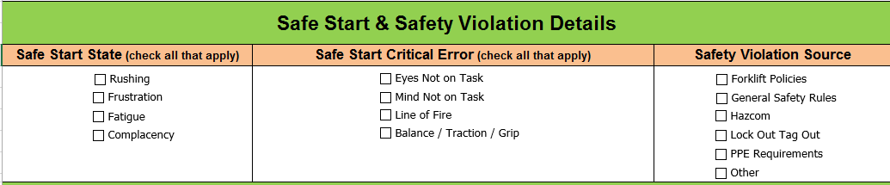

  - Insert pictures in the section that follows. Below that is the “Initial Action” section as shown below with instructions on information to include.

Describe any medical treatment the IW received. If seen at a clinic, note if they were released to regular duty or when a follow up appointment is scheduled for.

Use IW for Injured Worker instead of the Victim’s name. Do not use gender identifying pronouns (him/her or he/she).
Describe what has been done immediately to prevent a future accident from recurring. A more thorough analysis will be done on the pages below in the REACT Analysis.

  - The final section on page 1 of the SA shows if a REACT Analysis will be conducted or not.

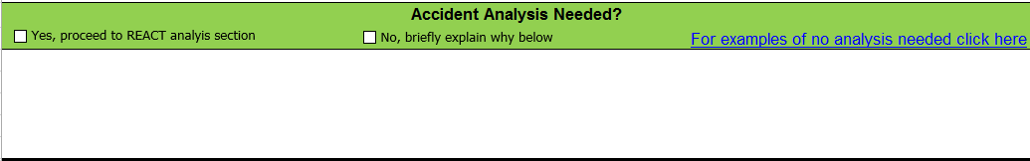
Click here for a list of reasons for NOT completing the REACT Analysis.

  - Now that you have completed page 1 of the SA, send the Excel version to your Safety contact for them to review, clarify, and edit the SA prior to communicating it to all CPG locations.
    - Spartanburg, SC – send to the Process Improvement Manager
    - All other locations – send to HRSupport@concept-pkg.com

  - The REACT Analysis must be completed, signed, and submitted to the Safety contact noted above within 72 hours from when the accident occurred.

