- Purpose

  - The purpose of this procedure is to provide a detailed set of instructions for completing a CPG Accident Report Form.

- Scope

  - The scope of this procedure applies to Supervisors with an employee, vendor, or visitor involved in an accident on CPG property. This form is to be used if there was bodily injury and/or if property damage occurred. The CPG Accident Report Form must be completed and submitted immediately (or by the start of the next shift) after the accident occurs.

Please see “Procedure HR-34 Safety Alert Form Completion” for detailed instructions on completing a Safety Alert within 24 hours after an accident occurs.

- Procedure

  - When conducting an accident investigation, it is important to be as thorough as possible and collect as much detailed information as you can. Whenever possible, take pictures of the accident scene, reenactments, and bodily injury.

  - After an accident occurs, regardless of the level of injury or property damage, a CPG Accident Report Form must be completed immediately (or by the start of the next shift). This form can be found on the server under \Human Resources\Public\HR Forms\Safety Forms as shown below. Copy the file to your desktop in order to complete the form.

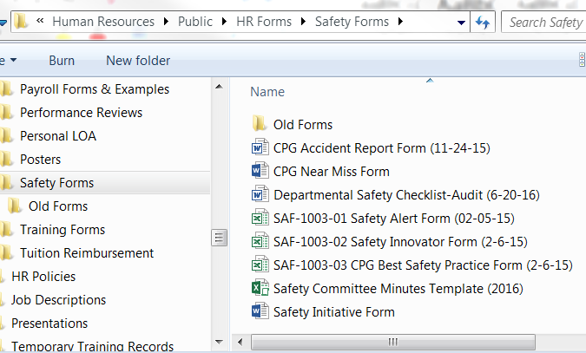

  - When you open the form, you will see 3 important notes at the top to complete the form in the following manner:
    - Typed on a PC – do not hand-write on the form
    - Complete, sign, and submit the first 3 pages of the accident form
    - Submit only a copy signed by all involved (injured EE, 1st Responder, Supervisor, Witness, etc.)

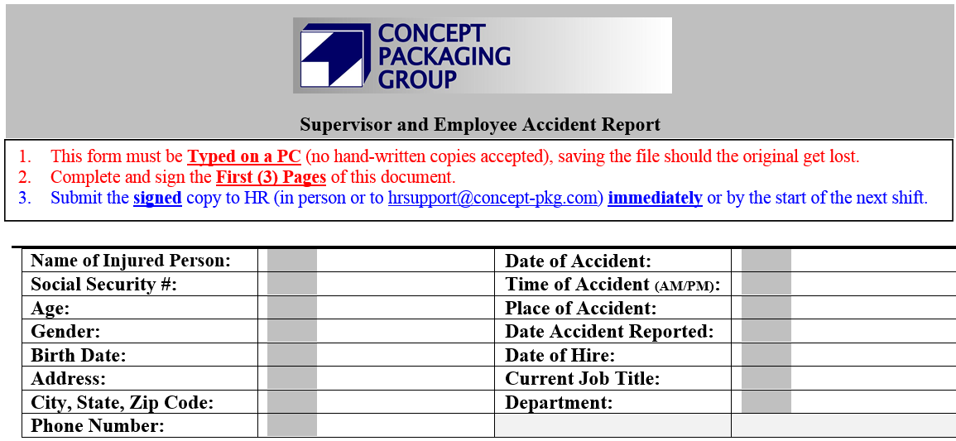

  - When completing the remainder of page 1 of the form, be as specific as possible. Keep in mind that any accident involving medical treatment beyond in-house 1st Aid must be submitted to our Worker’s Compensation provider. The HR Department is responsible for this and needs as much information as possible in order to do this effectively.

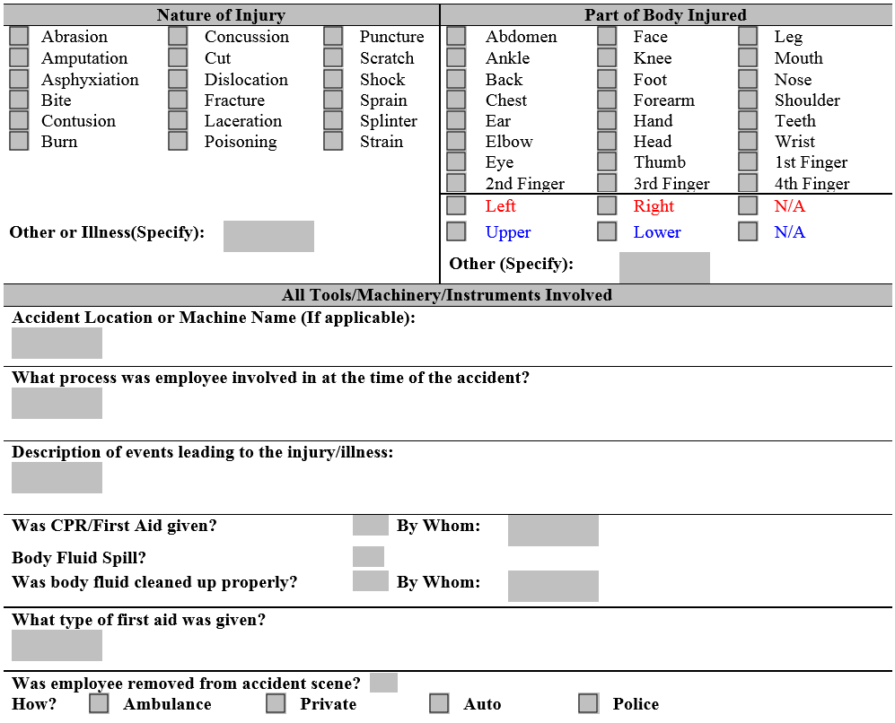

  - Get Witness statements whenever possible and type them in the form. Once printed, have the Witness sign this section.

**If there are no witnesses, write N/A in the space so we know it wasn’t simply overlooked.

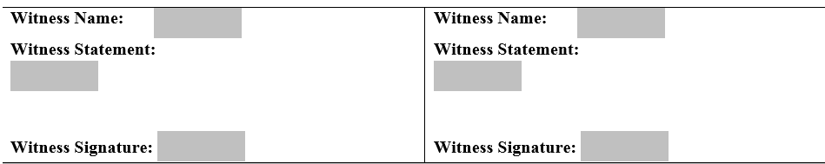

  - The next section needs to be completed using the answers from the Accident Victim, as noted. Do not assume that you know why the accident occurred. These answers are critical in preventing the same or similar accidents from recurring.

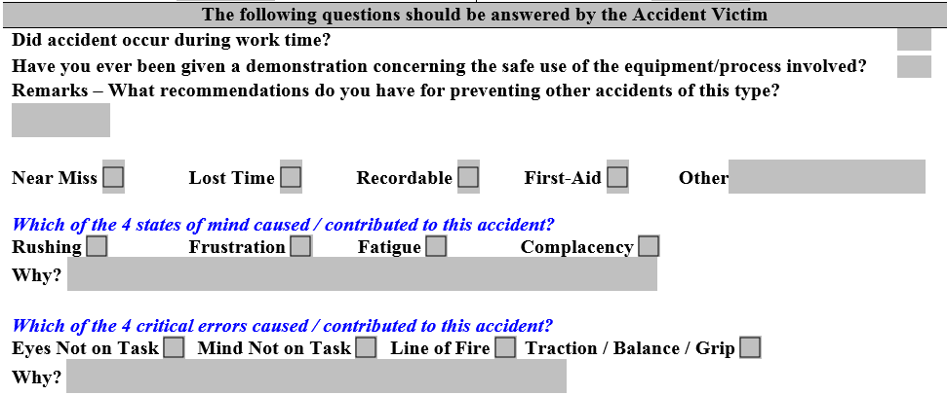

  - Now you can print the first 3 pages of the form (and keep a saved copy should it get lost) in order to obtain signatures of everyone involved. Note that the EE involved in the accident must sign and date in 2 places as noted below:
    - The first is to attest that they are refusing medical treatment (if applicable).
    - The second is signing off on the accuracy of the accident form.

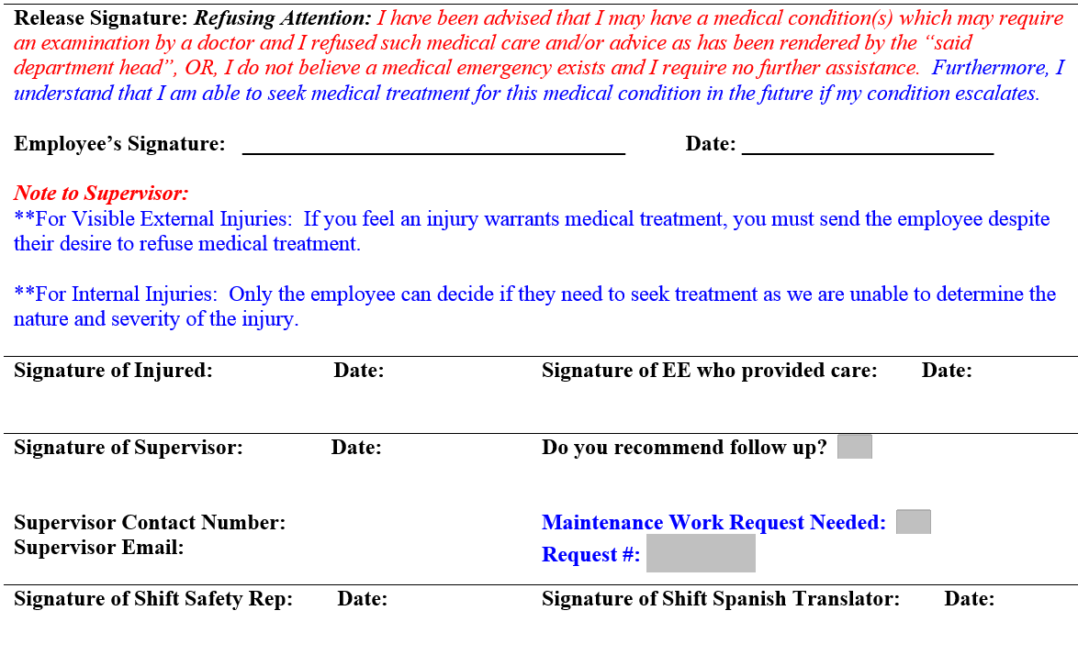
These notes will help the Supervisor in determining whether medical treatment is necessary.
The EE involved in the accident and anyone involved in the investigation must sign here, attesting to the accuracy of the accident report.
Injured EE signs here IF medical treatment is refused.

  - Proceed to page 3 of the Accident Report Form. Read and sign this form, then submit all 3 pages as instructed in the next step.

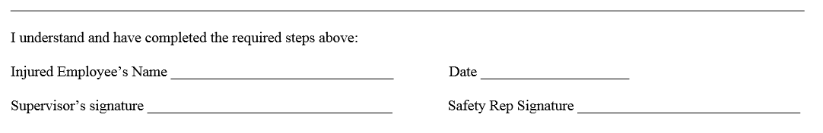

  - Scan the signed copy of the Accident Report Form and email it to HRSupport@concept-pkg.com, and attach any pictures taken during the investigation.

  - Please see “Procedure HR-34 Safety Alert Form Completion” for detailed instructions on completing a Safety Alert within 24 hours after an accident occurs.

  - The HR Department is responsible for completing the following processes upon receipt of an Accident Report Form:
    - Reporting the accident to CPG’s Worker’s Compensation insurance provider within 24 hours after the accident occurred.
    - Updating the OSHA log, if applicable.
    - Deducting any Safety Leadership Points in PeopleTrak.
    - Noting the Accident and details in the EE’s PeopleTrak record (which you can view in the Event History button on the EE’s Status screen as shown below).
    - Filing the report in the EE’s Medical file.

