- Purpose

  - The purpose of this procedure is to provide detailed instructions for properly completing training requirements for job changes and new hires.

- Scope

  - The scope of this procedure applies to Managers, Supervisors, and Leads that are training new hires and employees with a recent job change (promotion, demotion, transfer, etc.).

- Responsibility

  - Managers, Supervisors, and Leads are responsible for completing training requirements timely and properly. HR is responsible for making sure training requirements are processed correctly.

- Procedure

  - New Hire Training
    - When a new employee is hired, a CPG new hire orientation training form needs to be completed within 90 days.
        - New hire training forms for the SAO can be found on the central shared drive at \\conceptdom\central share\Quality_ScGa\Quality Management System\QSP6 Forms
        - New hire training forms for the NAO can be found on the Georgetown shared drive at \\georgetown\shared\Quality_Ky\QSP6 Forms

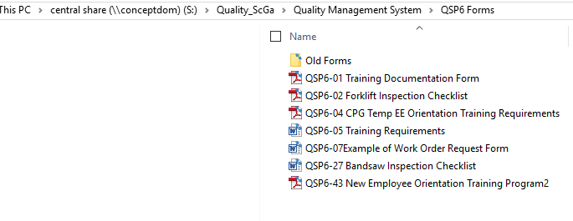

SAO

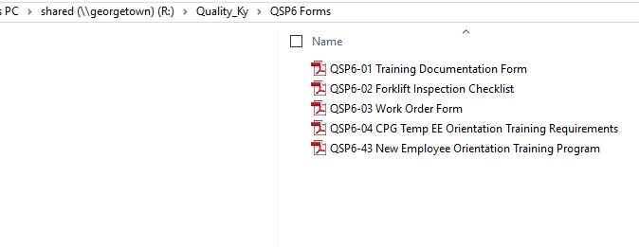

NAO

    - When completing the new hire training form, the top of the form should be completed which includes the employee, hire date, and position sections. See below screenshot.
    - Each training topic must have a date and signatures from both the trainee and the trainer.
    - Once the form is completed, turn it in to the HR Support Desk at HRSupport@concept-pkg.com.
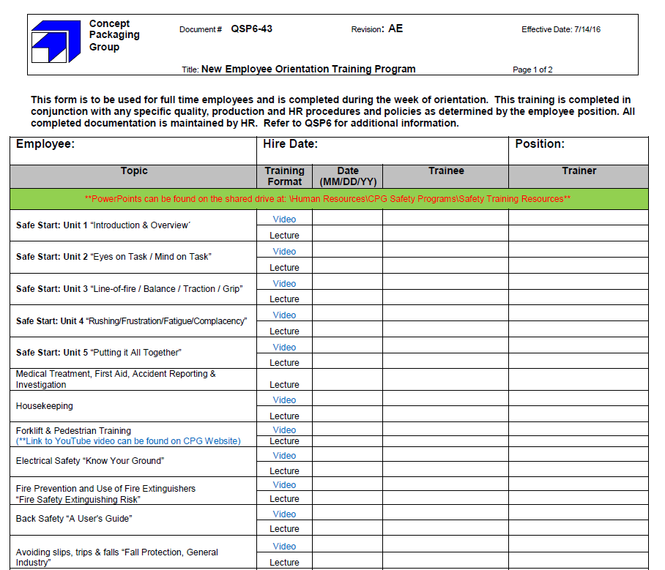

When completing the new hire training form, the top sections should be completed and every topic should be signed and dated by both trainee and trainer.

  - Job-Specific Training
    - When an employee moves to a new position or when an employee is a new hire, their job specific training form (QSP6-05) is due within 90 days.
        - Job training forms for the SAO can be found on the central shared drive at \\conceptdom\central share\Quality_ScGa\Quality Management System\QSP6 Training Requirements
        - Job training forms for the NAO can be found on the server at \\georgetown\shared\Quality_Ky\QSP6 Training Requirements. See screenshots below.
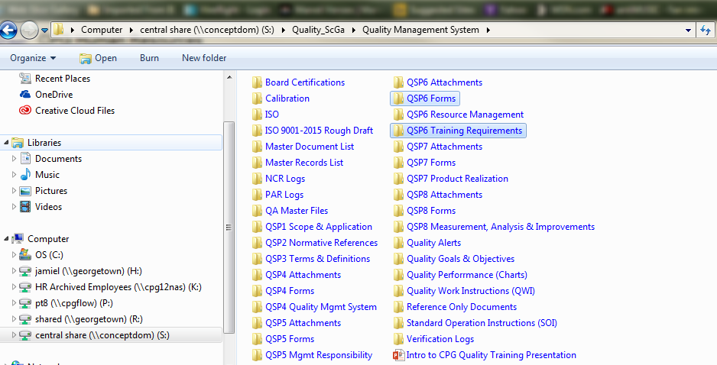

SAO

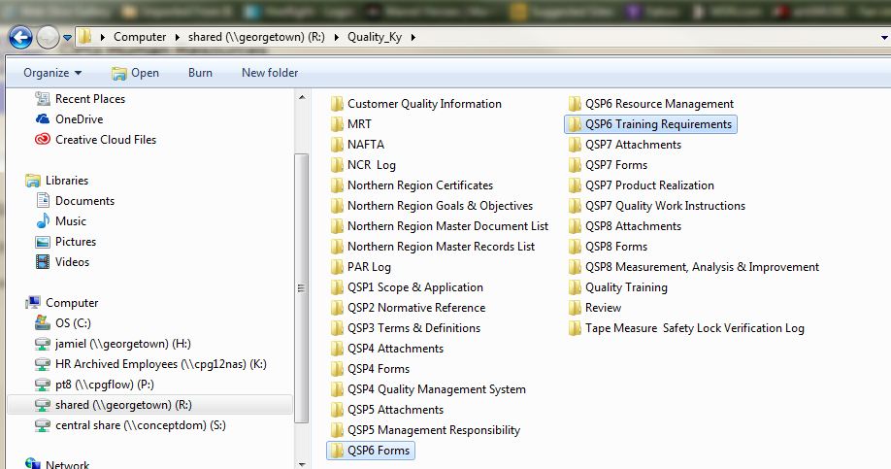

NAO

NAO

Note: The job title on the job-specific training form (QSP6-05) has to match the Job Title in PeopleTrak EXACTLY.

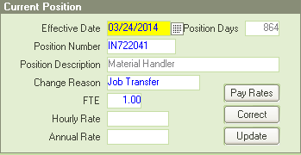
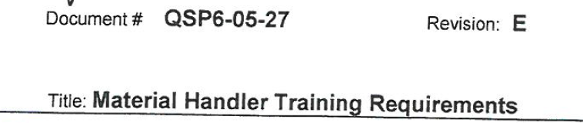

    - When completing the job training form, make sure that the top is filled out and also each line has a date and a signature for both the employee and the trainer.
        - If you have a training topic that doesn’t apply to the job you are training on, please get with quality to have the training form CHANGED, as we can’t accept training forms with N/A in place of signatures. See below screenshots.

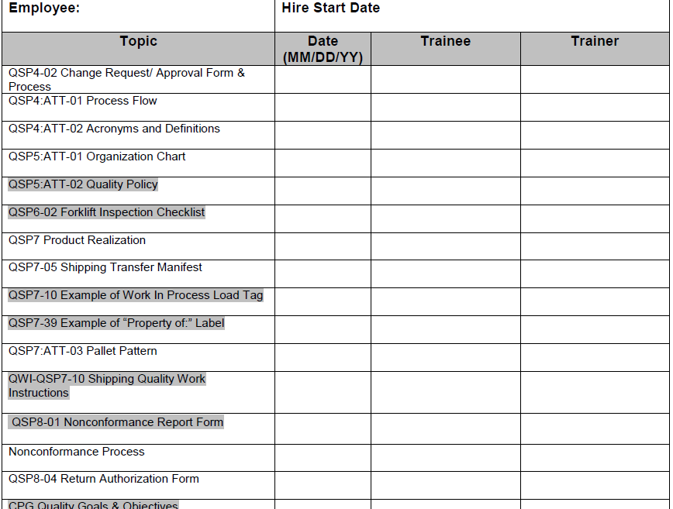
The employee’s name and hire date should be at the top.

Each topic should be dated with the employee’s and the trainer’s signature.

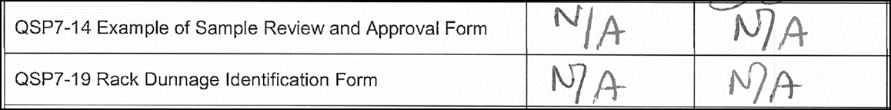
Training forms with N/A in place of signatures are unacceptable.

