- Purpose

  - The purpose of this procedure is to provide detailed instructions for properly terminating an employee at CPG.

- Scope

  - The scope of this procedure applies to Managers and Supervisors when the need arises to end the employment of a full-time CPG employee. The following topics are addressed:

- Termination Reasons
- Termination Preparation & Process
- Termination Paperwork

- Termination Reasons

  - There are 4 main reasons why an employee has reached termination status:

    - They have been counseled through the Corrective Action Program without improving the behavior being addressed. They have progressed from a verbal counseling to a written counseling, and their continued behavior now warrants termination.

    - They have received a written counseling within the first 60 days of their employment (which is considered a probationary period).

    - They have received 2 written counselings for any reason within a 12-month period.

    - They have had a performance issue that is considered to be Gross Misconduct, and their actions warrant immediate termination. Please see the CPG Handbook for a list of issues that fall into this category. HR must be consulted prior to issuing terminations for Gross Misconduct.

- Termination Preparation & Process

  - If the need arises to terminate an employee, it is important that the employee remains at work until you are ready to address the termination with them. Do not send them home to confirm that a termination is warranted. They will most likely not return the next day to receive their termination counseling.
    - If you are on 2nd or 3rd shift, send an email to the HR Support Desk with any questions (HRSupport@concept-packaging.com). If you don’t get a timely response, call someone in the HR Department directly.

  - If an investigation is needed, obtain witness statements from other employees, and be sure they sign and date their statement. Keep all investigation notes that help support the termination. All information provided will be used by HR when responding to any unemployment claims made by the terminated employee.

  - A termination counseling must be written using the Employee Counseling form as the means of addressing the termination with the employee. The form can be found on the server as shown below under Human Resources\Public\HR Forms\Counseling Forms. NOTE: If the termination is for attendance or a No Call/No Show, the HR Department will draft the counseling form and send it to you.

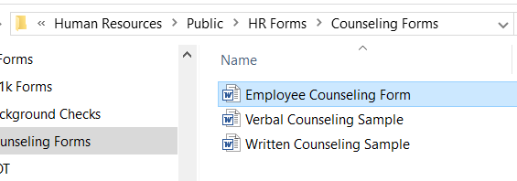

  - When drafting the Termination Counseling, the suggestions noted below may assist you. If you need assistance, do not hesitate to ask HR for assistance.

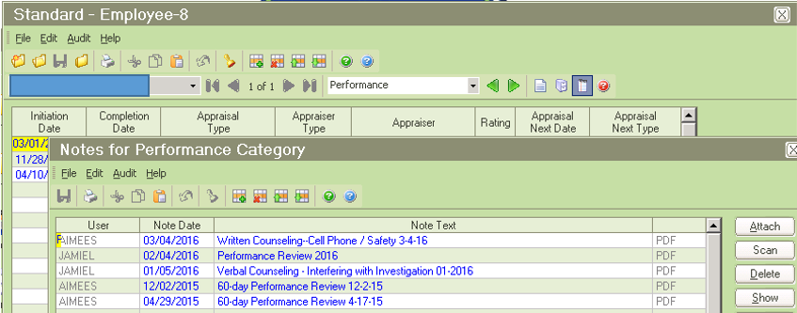
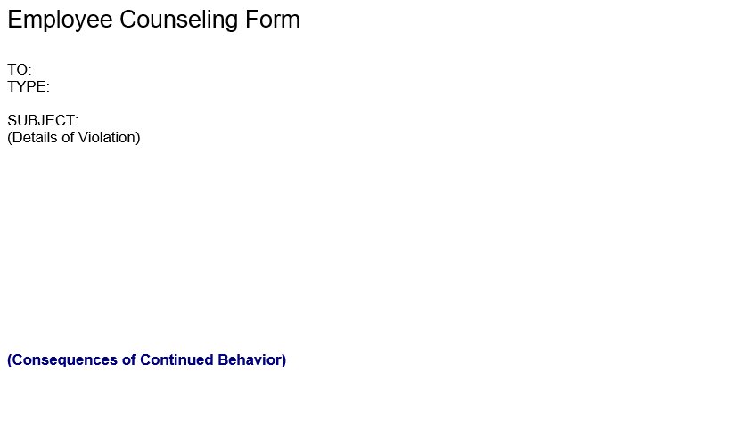
Previous counselings can be found on the Performance Tab in PeopleTrak. Click on the Notes icon at the top to open the Notes screen. To see the counseling, select the line and click the Attach button on the right side as shown above.
- Note the most recent behavior, and include the date and details.
- Reference any other counseling(s) that have led to the progressive discipline.
- If it is immediate termination due to gross misconduct, reference the Handbook section supporting your decision to terminate.
- Address that they were warned that any future violation would result in termination of employment, if applicable.
- State that their employment is terminated as a result of their continued behavior.
- Include the effective date of termination.

  - All terminations must be conducted by a Supervisor or Manager (not a Lead). Always have a witness present during any counseling, including a termination.

  - You will need to have 2 documents with you for the termination counseling:
    - The counseling form
    - A completed Payroll Action Form (PAF)

  - For the Counseling Form:
    - Please be sure that the document is signed by the employee, yourself, your manager, and a witness.
    - If the employee does not sign the termination counseling document, write “Refused to Sign”.
**NOTE: Verbal and Written counselings must always be signed.**
    - The employee may write any comments they choose in the last section of the document.

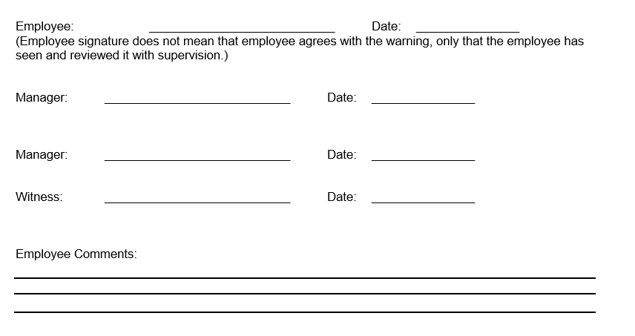

  - For the PAF:
    - Include the effective date at the top and also mark Termination.
    - Enter their personal data at the top (found in PeopleTrak), then confirm that the address on file is where their W-2 should be mailed.
    - Complete the Separation section at the bottom of the form (shown below), noting the Separation Reason and if they are Eligible for Rehire. If they are not eligible for rehire, note why in the Comments section below.
(Note: Payroll will complete the Vacation and Safety Leadership sections upon receipt.)
    - If the employee has a CPG cell phone that you are collecting, you must get their Apple ID and Password for IT to use for the reasons stated.
    - The employee and manager both need to sign and date at the bottom.

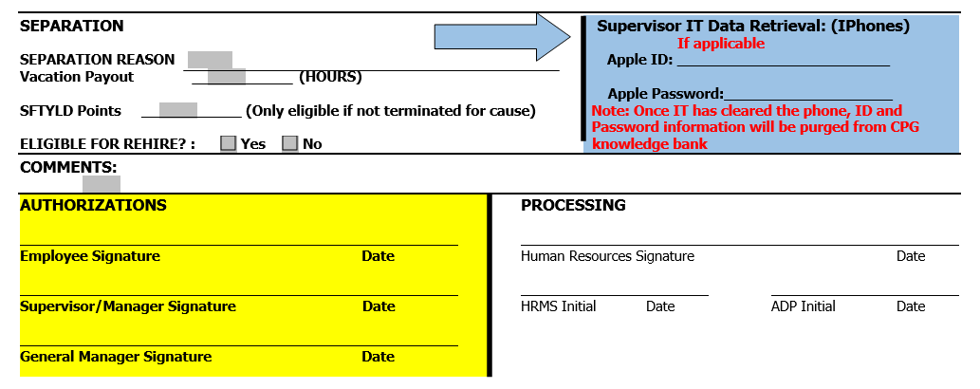

- Termination Paperwork

  - Submit termination paperwork in the following manner:
    - PAF – send to the Accounts Payable Clerk for your region
(Note: They will obtain the GM’s signature and date before processing)

    - Counseling Form and any Investigation Notes or Witness Statements – send to the HR Support Desk

