- Purpose

  - The purpose of this procedure is to provide a detailed set of instructions on how to properly complete the CPG 401k Enrollment Forms and submit it to Human Resources.

- Scope

  - The scope of this procedure encompasses steps on how to enter the proper information on the 401k enrollment forms and how to present it to the HR department so that proper 401k decisions are chosen. In most instances HR will meet with the employee (EE) to aid in completing this form. However, EE’s at outside locations as well as salespersons will complete these forms in most instances without HR presence.

- Procedure

  - When a new hire is brought aboard, there is a 6 month waiting period to become eligible for 401k. CPG will make every attempt to complete the 401k enrollment process after 5 months of employment.
    - CPG sites with HR presence—HR will be responsible for completing this form with all hires.
    - CPG sites without HR presence—Site MGR will be responsible for completing the forms and submitting them to HR. HR will be responsible for reminding Site MGR of their due date.

  - Select the CPG 401k Enrollment form/packet from the server. The form can be accessed via this link: 401k Enrollment Pack
    - Screenshot below shows the actual enrollment form that will need to be accessed.

    - The following are a checklist of items that should have been covered with the employee PRIOR to them completing their 401k paperwork.
      - The Principal 401k 25 minute video which can be located here: 401k EE Video
      - The CPG 401k PowerPoint Presentation which describes the CPG plan specifics, which can be located here: CPG 401k PowerPoint Presentation
    - Screenshots below will cover all sections of pages 1-4 of the CPG 401k Enrollment form. Depending on the packet given to the EE, the page numbers may vary in the enrollment kit. Section 1, the “My Personal Information” section will need to be completed and it MUST be legible.
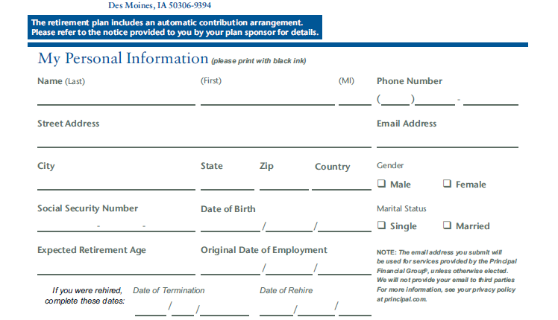
Information is pretty straight forward.

    - Section 2, “My Coverage Action should be completed next.
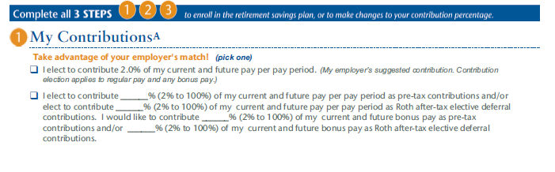
For most EE’s the 2nd box will be chosen if they wish to contribute more than 2% of their pay to receive the full benefit of the company match of $.50 on the 1st 4% contributed. This is the standard, pre-tax contribution level

For most EE’s, they need to place their contribution amount on the 1st line, and avoid the others. If they wish to contribute to the ROTH, they need to speak with a CPG HR representative to understand its’ implications.
EE’s who do NOT wish to contribute to the plan can skip the 1st 2 boxes and immediately go to page 3 to opt out.
For most EE’s the 1st box SHOULDN’T be selected. This is a flat 2% deduction ONLY per pay period.
For n

    - Section 2, My Contributions continued, if the EE does NOT wish to contribute, simply have them check the box highlighted below and they can proceed to page 4, sign and date the form and they are finished.
EE’s who do not wish to contribute, check this box. Then proceed to page 4, sign and date the form and they are finished.
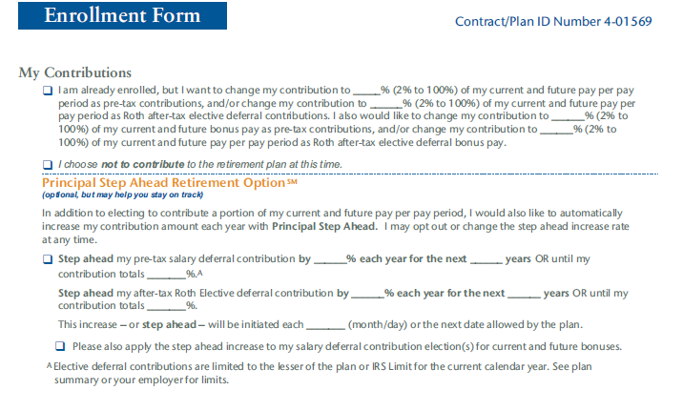
    - Section 3, My Investment Choices is often overlooked. Here, EEs must decided where to invest their money. They have 2 choices:
1. Choice A is the DO-IT-FOR-ME option. Here, Principal invests 100% of your funds into one of the Lifetime Portfolio accounts based upon your current age and anticipated retirement typically at age 65. For example, a 20 year old EE would have their funds go into the portfolio 40 years from now based upon expected retirement age. That would typically be the 2050 or 2060 plan.
2. Choice B is the do it myself approach. This is where the EE tells Principal where to invest their funds. The EE can place them anywhere they like as long as they are in PERCENTAGE amounts. For example, if an EE chose 5 funds and wanted to place their contributions in those 5 accounts, they can do so as long as they all add up to 100%. To keep the math simple in this example, they could simply place 20% on the line for each account which would add up to 100% .

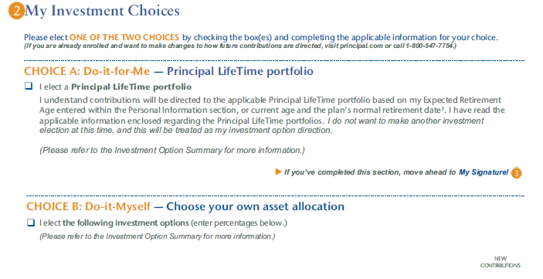
EE’s who wish to contribute and want control on where their contributions will go, check this box. Then proceed to make your selections next to the fund(s) you wish to purchase in PERCENTAGES on page 4, sign and date the form and they are finished.
EE’s who want to contribute to the plan, but do not wish to be bothered with where to place their contributions, simply check this box. Then proceed to page 4, sign and date the form and they are finished.

    - Section 4, My Signature is the final section of the 401k Enrollment form. Please sign and date this area.

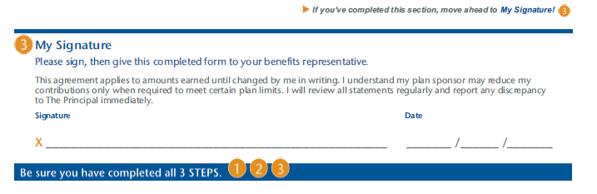

EEs who have CHOSEN to contribute to the plan, must next proceed to the Beneficiary Form to complete.
EEs who have CHOSEN NOT to contribute to the plan are finished!!!!
REMINDER
The Beneficiary Form is ONLY for EEs who have CHOSEN to contribute to the plan.
    - Section 1, Personal Information. This section is where any EEs must complete basic personal information once again..
Information is pretty straight forward.
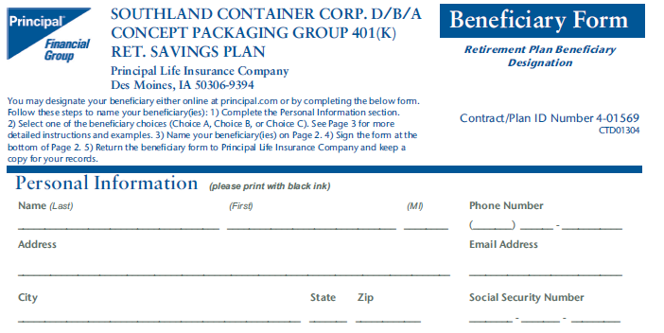

    - Section 2, My Beneficiary Choices. This section is very important! The Internal Revenue Service (IRS), places strict guidelines here.
- IF you are married, you have to name your spouse as a beneficiary.
- IF you are married and your spouse signs the waiver below, ONLY then can you name any beneficiary that you chose.
- IF you are separated and going through a divorce, you are advised not to contribute to the plan as your spouse will be entitled to HALF of all funds you place in the 401k plan until the divorce is FINALIZED.
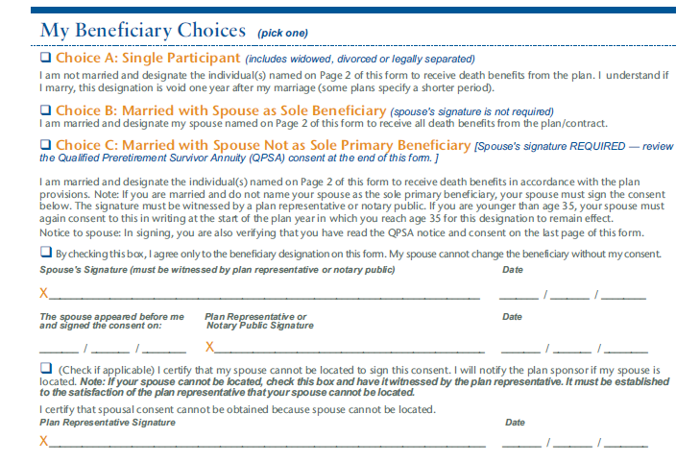

3.2.10 Section 3, Naming My Beneficiary(ies). This section is the place where you will inform Principal where your funds will go upon the event of your death. There are 2 types of beneficiaries.
1. Primary—these are the person(s) that all of your funds will go to upon your death. The form is designed to provide up to 2 names allowing you to provide them a portion of your funds as long as the shares add up to 100%. If you would like to name more primary beneficiaries, please speak with HR or your manager to assist you in completing your forms.
2. Contingent—these are the person(s) that all of your funds will go to upon your death if your Primary beneficary(ies) are no longer living or can not be located after a period of time.

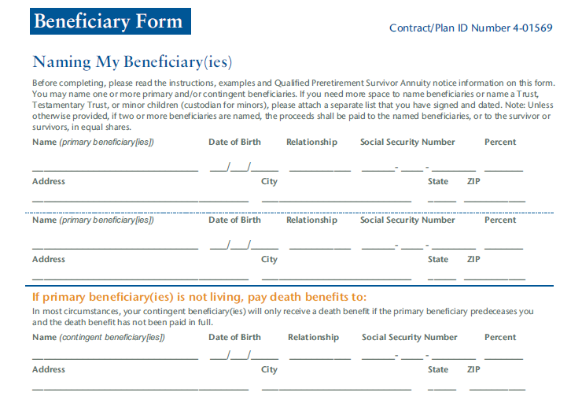

All sections must be completed and MUST be legible!!
You are highly encouraged to list BOTH Primary and Contingent Beneficiaries

    - Section 4, My Signature, complete this section and you are finished. Please make sure to sign and date this section.
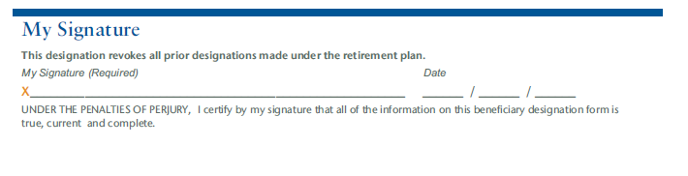

Things to remember:
- Don’t forget to sign and date all forms.
- Don’t forget to provide legible dates of birth and Social Security Numbers.
- Don’t forget to opt in or out of the 401k plan.

