- Purpose

  - The purpose of this procedure is to provide a detailed set of instructions on how to properly complete a CPG Healthcare (HC) Enrollment Form and submit it to Human Resources.

- Scope

  - The scope of this procedure encompasses steps on how to enter the proper information on the HC enrollment form and how to present it to the HR department so that proper HC plans are purchased. In most instances HR will meet with the employee (EE) to aid in completing this form. However, EE’s at outside locations as well as salespersons will complete these forms in most instances without HR presence.

- Procedure

  - When a new hire is brought aboard, there is a 60-day waiting period to become eligible for HC. CPG will make every attempt to complete the HC enrollment process around 45 days into the employment process.
    - CPG sites with HR presence—HR will be responsible for completing this form with all hires.
    - CPG sites without HR presence—Site MGR will be responsible for completing the forms and submitting them to HR. HR will be responsible for reminding Site MGR of their due date.

  - Select the CPG HC Open Enrollment form from the server. The form can be accessed via this link: ..\..\Public\HR Forms\Health Care

    - Screenshot below shows the actual enrollment form that will need to be accessed.

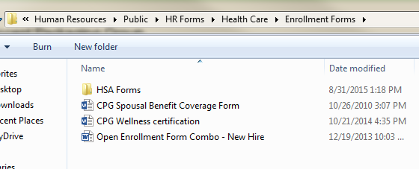

    - Screenshots below will cover all sections of page 1 of the CPG HC Enrollment form. Section 1, Employee Identification will need to be completed and it MUST be legible.
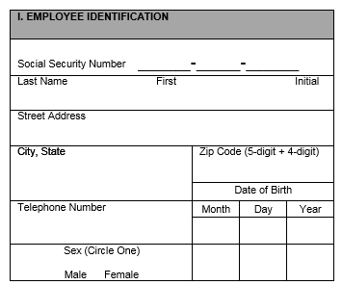
Information is pretty straight forward.

    - Section 2, Coverage Action should be completed next. 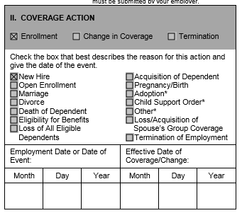
For new hires, this date is the Sunday after their 60-day eligibility date. For example, if a new hire’s 60-day eligibility date were to fall on a Thursday, then the date you place in this box is the following Sunday. This date will ALWAYS be a Sunday
For new hires this date the Sunday after their 60-day eligibility date. For example, if a new hire’s 60-day eligibility date were to fall on a Thursday, then the date you place in this box is the following Sunday. This date will ALWAYS be a Sunday
For new hires this date the Sunday after their 60-day eligibility date. For example, if a new hire’s 60-day eligibility date were to fall on a Thursday, then the date you place in this box is the following Sunday. This date will ALWAYS be a Sunday
For new hires, this date is ALWAYS their hire date

    - Section 3, Beneficiary Information, is referencing to the $20,000 of free life insurance CPG provides to all EE’s regardless of whether they elect HC coverage. 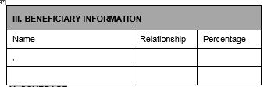

For example,
Name Relationship Percentage
Michael Jordan Father 100%

    - Section 4, Additional Information is often overlooked. Here, quesitons regarding the use of tobacco products as well as spousal coverage are asked. Depending on the answer, pages 2 and/or 3 may need to be completed. If the EE is waiving coverage, you can leave this section blank.
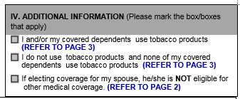

    - Section V, Coverage is the section where the actual HC selections are chosen. Please review this one carefully.

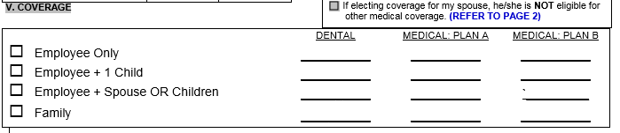

This section of the form can have several different combinations. The most common are all under the same selection type such as “Employee Only”. In this example, the EE may select Dental and Plan B by placing a check box under both columns, like shown above.

Other times, the EE may select Single HC coverage, but place their family on the Dental which would require entering the information on multiple lines.

    - Section 6, Dependents. This section is where any dependents going onto the HC plan must have their information listed. All boxes must be filled in for each dependent listed.
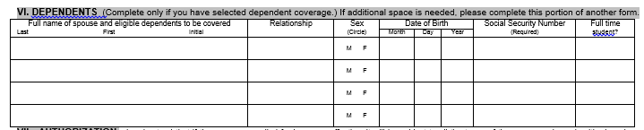

SAMPLE
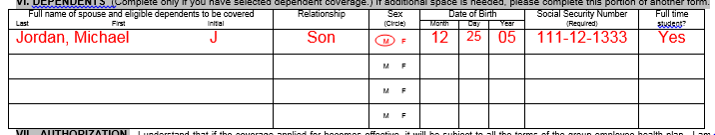

    - Section 7, Authorization. This section ONLY needs to be completed if the EE is accepting Dental and/or Medical Coverage. If they aren’t electing one or both of these, then they can skip this section.

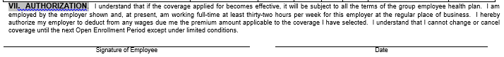

    - Section 8, Waiver of HC, this section must be completed any time an EE is waiving Medical and/or Dental coverage. If they are waiving it for themselves, spouse or children it needs to be noted below. If their spouse can’t come onto the plan due to having coverage elsewhere, it is typically ok to leave this section blank as they can’t enroll into CPG’s plans.
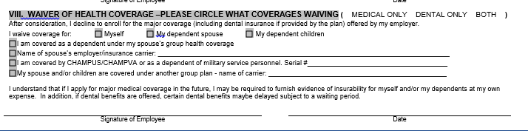

Things to remember:
- Don’t forget to circle the type of coverage the EE is waiving.
- Don’t forget to check the box of the family member coverage is being waived on
- Don’t forget to sign the bottom of the section

  - Page 2 spousal coverage:
    - This page typically only needs to be completed if the EE is placing their spouse on one or more of the CPG HC plans.

  - Page 3 tobacco use:
    - This page needs to be completed if Medical coverage was elected to identify the tobacco use of the EE and any dependents enrolled.

