- Purpose

  - The purpose of this procedure is to provide detailed instructions for completing an employee’s promotion, demotion, or transfer.

- Scope

  - The scope of this procedure applies to Managers, Supervisors, and Leads that are promoting, demoting, or transferring an employee. It details how to complete a Payroll Action Form (PAF), who to send it to once it is completed, and how to complete a 60-day performance review and job-specific training.

  - This procedure requires the following items for completion:
    - Completing a PAF using information in PeopleTrak and the Pay Rates spreadsheet
    - Completing a Performance Review after 60 days on the job
    - Completing the Job Training Form QSP6-05 within 90 days after the job change

- Procedure

  - When an employee is promoted, demoted, or transferred, a PAF (Payroll Action Form) needs to be completed.
    - Payroll Action Forms can be found on the server at Human Resources\Public\HR Forms\Payroll Forms & Examples\Payroll Action Form (PAF). See screenshot below.

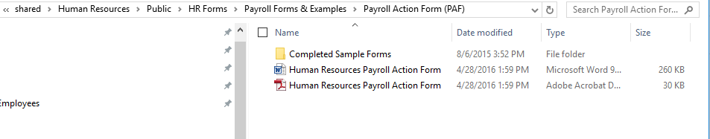

    - PAF Screenshot:
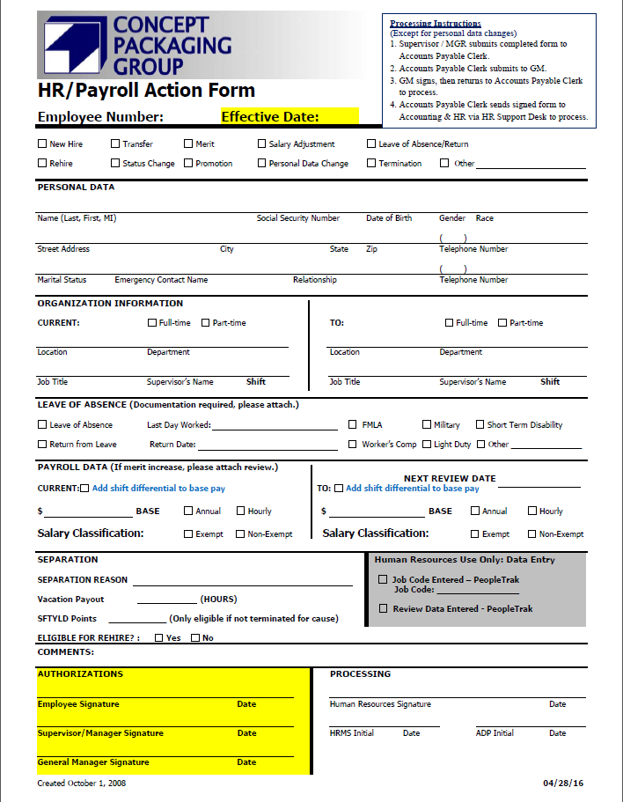

  - Employee Number / Effective Date / Status Type / Personal Data
    - When filling out a PAF, the Employee’s Number needs to be given and also the Effective Date.
      - The effective date when moving an employee should ALWAYS be on a Monday. If the Monday is a holiday, then the effective date can be that Tuesday. The exception to this is when an employee is terminated.
    - The status type box needs to be marked that represents the type of move the employee is making. For example, if the employee is being promoted then the promotion box needs to be marked.
    - For the Personal Data section, confirm that their personal data in PeopleTrak is still correct. If so, leave this section blank. If not, complete this section and also check the “Personal Data Change” box in addition to the job change being made.

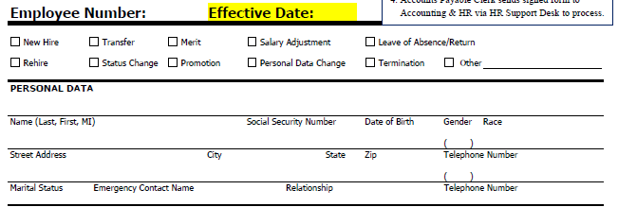
These boxes represent the type of move the employee is making.

  - Organization Information / Payroll Data
    - For both the employee’s Job Title and Pay rate, make sure to check PeopleTrak for the correct information. See below screenshot.
      - If you need guidance navigating to the employee’s Position History screen, please see “Procedure HR-32 PeopleTrak Overview for Supervisors”.
The Job Title and Pay rate can be found on the employee’s Position History screen. Make sure this is what you are looking at when completing the PAF.
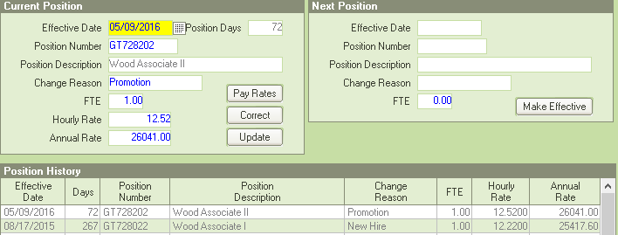

    - The Organization Information section should have the employee’s Location, Department, Job Title, Supervisor, and Shift filled out. Full-time or Part-time should also be marked. See below screenshot for example.
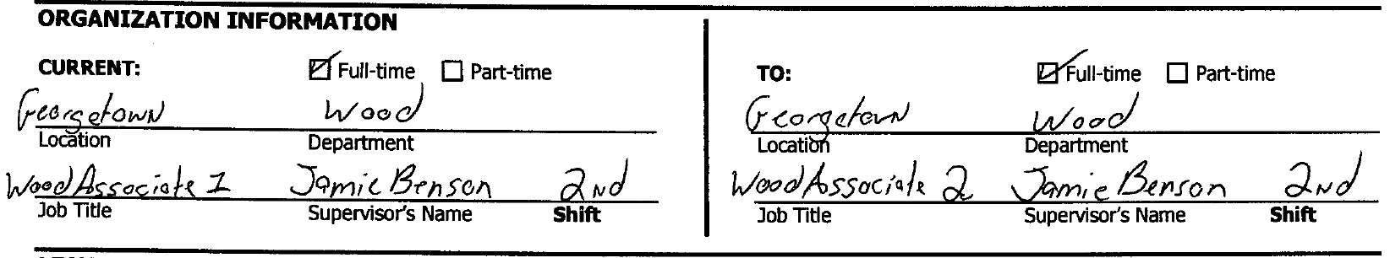

    - The Payroll Data section should include the employee’s base pay and their salary classification should be marked. If the employee is working 2nd shift, then the “Add shift differential to base pay” will be marked. See below screenshot for example.

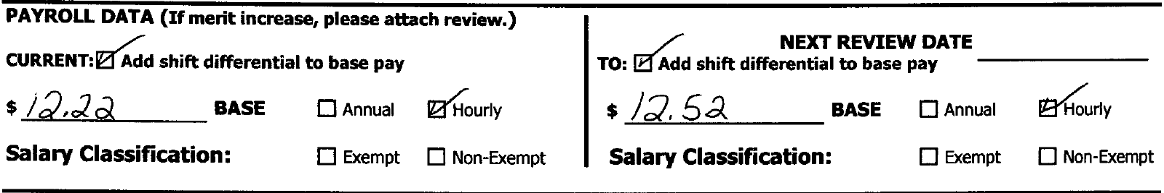
    - To get the correct Pay Rate for their new position, make sure you are referencing the Pay Rates spreadsheet for all positions at CPG. This can be found on the server at \Human Resources\Public\HR Forms\Pay Rates - All Locations as shown below.
      - Shift differentials are not calculated in the pay rates that are listed here, so it is imperative that the “Add shift differential to base pay” box is checked when completing the PAF.

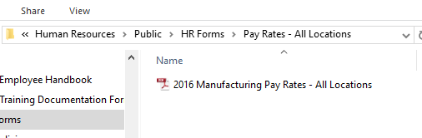

  - Authorizations

    - Before turning in a PAF, make sure both the employee and supervisor sign and date the form.
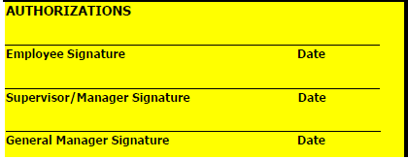

  - Processing Once Signed by Supervisor
    - After the PAF is signed and dated by the supervisor and the employee, the supervisor should give the form to the Accounts Payable Clerk for their region. Once the Accounts Payable Clerk receives the form, it is then sent to the region’s General Manager for their signature. Once the General Manager signs, it is sent back to the Accounts Payable Clerk.
    - The Accounts Payable Clerk then sends the PAF to both Accounting and HR through the support desk (HRSupport@concept-pkg.com) for proper processing.

  - Performance Review
    - Performance Review forms can be found on the server at Human Resources\Public\HR Forms\Performance Reviews\60-day Review Forms

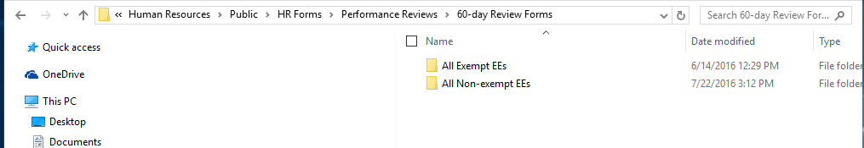

    - Once the employee is moved to their new position, a 60-day performance review must be completed once 60 days has passed from the day they were moved. For example, if the employee was promoted effective 7/5/16, then the 60-day performance review would be due 9/5/16.
      - If the employee is moving up in Assembly or Press, then a 60-day performance review would not need to be completed.

      - When completing the Performance Review, please make sure everything is signed and dated and that the employee’s score is calculated correctly at the bottom of the form. See screenshot below.
      - Once the Review is completed send the form to the HR support desk. (HRSupport@concept-pkg.com)
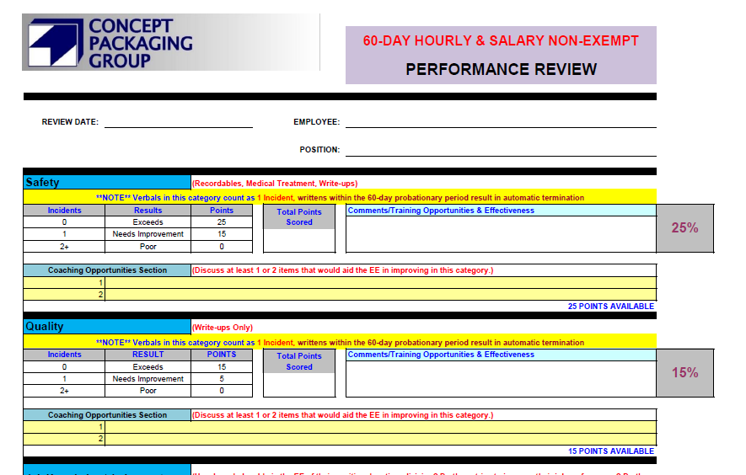

All lines should be completed and all areas should be given a score with comments for the employee to view.

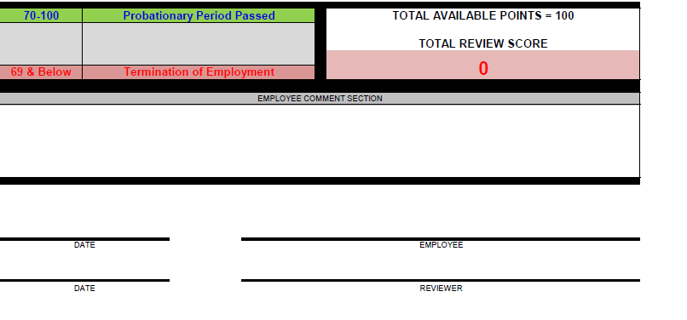
A score should be calculated here and the bottom should be signed and dated.

  - Job-Specific Training
    - When an employee moves to a new position, their job specific training form (QSP6-05) is due within 90 days.
      - Job training forms for the SAO can be found on the central shared drive at Quality_ScGa\Quality Management System\QSP6 Training Requirements
      - Job training forms for the NAO can be found on the server at Quality_Ky\QSP6 Training Requirements. See screenshots below.
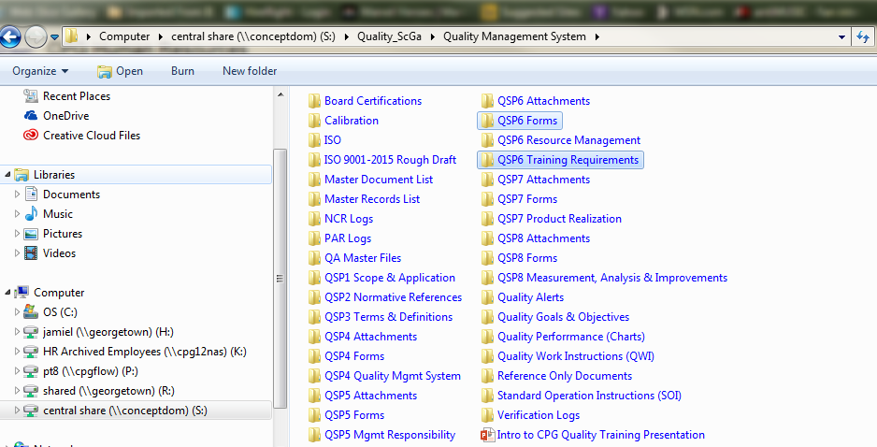

SAO

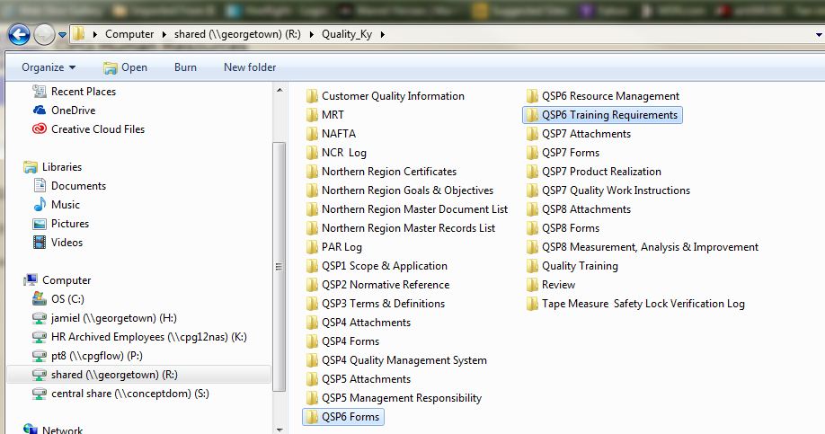

NAO

    - When completing the job training form, make sure that the top is filled out and also each line has a date and a signature for both the employee and the trainer.
      - If you have a training topic that doesn’t apply to the job you are training on, please get with quality to have the training form CHANGED, as we can’t accept training forms with N/A in place of signatures. See below screenshots.

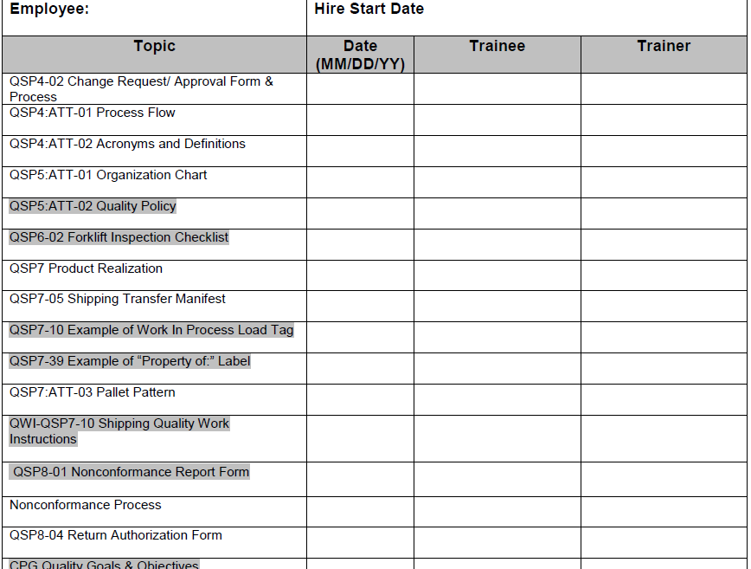
The employee’s name and hire date should be at the top.

Each topic should be dated with the employee’s and the trainer’s signature.

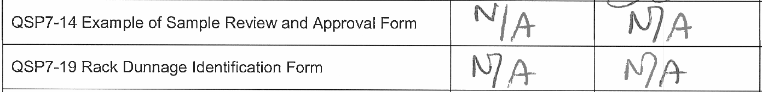
Training forms with N/A in place of signatures are unacceptable.

