- Purpose

  - The purpose of this procedure is to provide a detailed set of instructions on how to properly collect and present a CPG employee’s (EE’s) direct deposit (DD) information to the Payroll Department.

- Scope

  - The scope of this procedure encompasses steps on how to collect the DD information and how to present it to the Payroll department so that proper electronic DD funds are processed. CPG will follow the pre-noting process for all CPG new hires and EE switching of banks for DD. This process typically takes 2 payroll cycles. That would translate to 2 weeks for Hourly and Salary Non-exempt EE’s and 4 weeks for Salary Exempt EE’s. Sometimes the process may take less time, but HR is to instruct all EE’s of the time frames discussed above.

- Procedure

  - When a new hire is brought aboard, it will either be an External hire or an Internal hire, most likely the latter being a temp to hire situation. All EE’s must present to CPG visual evidence of their DD selection. We will NOT accept any DD information without visual documentation. EE’s will not be allowed to work without proper DD set-up with CPG. We do not pay via non-DD methods.
    - External hires—HR will be responsible for informing all external hires of the CPG DD process. HR will be responsible for informing them if they can’t provide this upon their hire date, they will not be employed until such documentation is presented.
    - Internal hires—HR will be responsible for reminding CPG Supervisors/Managers of the DD requirement when applicants are entering the hiring process. CPG Supervisors/Managers will be responsible for ensuring that applicants have this documentation prior to them completing the new hire paperwork. Again, internal applicants will not be hired without this documentation.

  - Select the CPG DD form from the server. The applicant/EE can provide 2 types of documentation. A voided or processed check or a direct deposit bank informational form. CPG will not accept hand written bank information from the applicant / EE.

    - Screenshot below shows a valid example of a voided/sample check being used. The sample check must be taped to the top of the CPG DD form.

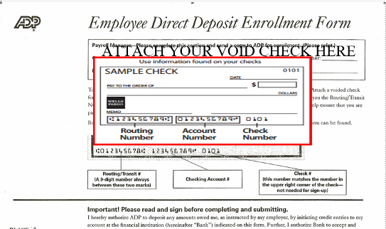

    - Screenshot below shows a valid example of acceptable documentation an applicant/EE may present in leui of a voided check. Also attached is a link to the form. ..\..\Public\HR Forms\Payroll Forms & Examples\Direct Deposit\Bank Direct Deposit Information Form---SAMPLE.pdf

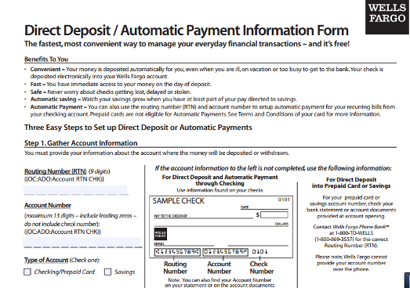
Document must be on a financial letterhead. The information in the RED CIRCLE to the right must be documented.

  - For applicant’s/ EE’s that have financial instutions such as the Money Network or Greendot, they must obtain information as outlined above. No exceptions.

  - CPG Financial Institution Partnerships.
    - CPG will reach out to local financial partners to offer applicant’s/EE’s the ability to obtain free checking accounts where ever possible. In the 2 manufacturing hubs, Gtown and Spartanburg, HR will reach out and manage this process.
    - For outside locations, the Facility MGRS can handle this partnership selection themselves or provide a list of financial instutions they would like HR to contact. If the latter is chosen, HR will reach out to these financial institutions and coordinate the program.
    - These financial partnerships shall be prominently displayed in EE break areas or other high traffic EE areas at CPG locations.

